Adaptive Employment Readiness Platform Using Real-Time Industry Skill Demand Mapping

CSA0925-Programming in Java

Papineni Sisindri(192324122)
Nihtish Raaju V(192411016)
Pavithran M (192411014)
Github link: https://github.com/nithish-7777/ParkPulseCampus

Pseudo code:

// ============================================================================

// PARKPULSE CAMPUS – SMART CAMPUS PARKING MANAGEMENT SYSTEM

// Unified Pseudocode (Full System)

// Tech Stack: Java Swing + JDBC + MySQL

// Database: parkpulse_db

// ============================================================================

// ============================================================================

// MODULE 1: DATABASE CONNECTION & PERSISTENCE LAYER

// ============================================================================

CLASS DBConnection:

CONSTANT DB_HOST = "localhost"

CONSTANT DB_PORT = "3306"

CONSTANT DB_NAME = "parkpulse_db"

CONSTANT DB_USER = "root"

CONSTANT DB_PASSWORD = "your_password"

STATIC connection = NULL

STATIC LOGGER = Logger

PRIVATE CONSTRUCTOR DBConnection():

// Prevent instantiation

STATIC FUNCTION getJdbcUrl():

RETURN "jdbc:mysql://" + DB_HOST + ":" + DB_PORT + "/" + DB_NAME +

"?useSSL=false&allowPublicKeyRetrieval=true&serverTimezone=UTC"

STATIC FUNCTION getConnection():

TRY:

IF connection == NULL OR connection.isClosed() OR NOT connection.isValid(2):

Class.forName("com.mysql.cj.jdbc.Driver")

connection = DriverManager.getConnection(getJdbcUrl(), DB_USER, DB_PASSWORD)

LOGGER.info("Connected to MySQL: " + DB_NAME)

RETURN connection

CATCH Exception e:

LOGGER.severe("DB connection failed", e)

THROW SQLException("DB connection failed", e)

STATIC FUNCTION testConnection():

TRY:

conn = getConnection()

RETURN (conn != NULL AND NOT conn.isClosed() AND conn.isValid(2))

CATCH Exception:

RETURN FALSE

STATIC FUNCTION closeConnection():

TRY:

IF connection != NULL AND NOT connection.isClosed():

connection.close()

LOGGER.info("MySQL connection closed.")

CATCH Exception:

LOGGER.warning("Could not close MySQL connection.")

FINALLY:

connection = NULL

// ============================================================================

// MODULE 2: DATA ENTITY MODELS (MODEL LAYER)

// ============================================================================

CLASS User:

ATTRIBUTES:

userId, name, role, department, phone, email, createdAt

CLASS Vehicle:

ATTRIBUTES:

vehicleId, userId, registrationNo, vehicleType, color, isEv, createdAt,

ownerName (joined from User)

CLASS ParkingZone:

ATTRIBUTES:

zoneId, zoneCode, zoneName, locationDescription, allowedVehicleTypes,

priorityOrder,

freeSlotsCount, occupiedSlotsCount, reservedSlotsCount, totalSlots

CLASS ParkingSlot:

ATTRIBUTES:

slotId, zoneId, slotCode, slotType, status, floor, xCoord, yCoord,

zoneCode, zoneName,

currentRegistrationNo, currentVehicleOwner, activeSessionId

CLASS ParkingSession:

ATTRIBUTES:

sessionId, vehicleId, slotId, entryDatetime, exitDatetime,

durationMinutes, baseFee, discount, finalFee, status,

registrationNo, vehicleType, isEv, ownerName, userRole,

slotCode, zoneCode

CLASS Reservation:

ATTRIBUTES:

reservationId, vehicleId, slotId, startDatetime, endDatetime,

status, createdAt,

ownerName, registrationNo, slotCode, zoneCode

CLASS Payment:

ATTRIBUTES:

paymentId, sessionId, amount, paymentMethod, paymentStatus, paidAt,

registrationNo, slotCode

CLASS Violation:

ATTRIBUTES:

violationId, sessionId, vehicleId, violationType, fineAmount,

status, remarks, createdAt,

registrationNo, ownerName, slotCode, zoneCode

CLASS ParkingPass:

ATTRIBUTES:

passId, vehicleId, passType, issueDate, expiryDate,

discountPercent, status,

registrationNo, ownerName

CLASS ParkingPolicy:

ATTRIBUTES:

policyId, zoneId, ruleName, ruleExpression, isActive,

zoneCode, zoneName

// ============================================================================

// MODULE 3: DATA ACCESS OBJECTS (DAO LAYER)

// ============================================================================

// All DAOs use DBConnection.getConnection() and PreparedStatement.

CLASS UserDAO:

FUNCTION getAllUsers():

sql = "SELECT user_id, name, role, department, phone, email, created_at FROM users ORDER BY user_id"

EXECUTE sql, map ResultSet → List<User>

RETURN List<User>

FUNCTION getUserById(userId):

sql = "SELECT ... FROM users WHERE user_id = ?"

EXECUTE sql, map → User OR NULL

FUNCTION getUserByEmail(email):

sql = "SELECT ... FROM users WHERE email = ?"

EXECUTE sql, map → User OR NULL

FUNCTION addUser(User u):

sql = "INSERT INTO users (name, role, department, phone, email) VALUES (?, ?, ?, ?, ?)"

EXECUTE INSERT, set generated userId in u

RETURN TRUE/FALSE

FUNCTION updateUser(User u):

sql = "UPDATE users SET name=?, role=?, department=?, phone=?, email=? WHERE user_id=?"

EXECUTE UPDATE

RETURN TRUE/FALSE

FUNCTION deleteUser(userId):

sql = "DELETE FROM users WHERE user_id = ?"

EXECUTE DELETE

RETURN TRUE/FALSE

CLASS VehicleDAO:

FUNCTION getAllVehicles():

sql = JOIN vehicles + users

RETURN List<Vehicle>

FUNCTION getVehiclesByUserId(userId):

sql = JOIN vehicles + users WHERE user_id = ?

RETURN List<Vehicle>

FUNCTION getVehicleById(vehicleId):

sql = JOIN vehicles + users WHERE vehicle_id = ?

RETURN Vehicle OR NULL

FUNCTION getVehicleByRegistrationNo(regNo):

sql = JOIN vehicles + users WHERE registration_no = ?

RETURN Vehicle OR NULL

FUNCTION addVehicle(Vehicle v):

sql = INSERT INTO vehicles (...)

EXECUTE INSERT, set generated vehicleId

RETURN TRUE/FALSE

FUNCTION updateVehicle(Vehicle v):

sql = UPDATE vehicles SET ... WHERE vehicle_id = ?

RETURN TRUE/FALSE

FUNCTION deleteVehicle(vehicleId):

sql = DELETE FROM vehicles WHERE vehicle_id = ?

RETURN TRUE/FALSE

CLASS ZoneDAO:

FUNCTION getAllZonesWithStats():

sql = SELECT zone fields + subqueries for free/occupied/reserved/total slots

RETURN List<ParkingZone> with stats filled

FUNCTION getZoneById(zoneId):

sql = SELECT ... FROM parking_zones WHERE zone_id = ?

RETURN ParkingZone OR NULL

FUNCTION getZoneByCode(zoneCode):

sql = SELECT ... FROM parking_zones WHERE zone_code = ?

RETURN ParkingZone OR NULL

FUNCTION addZone(ParkingZone z):

sql = INSERT INTO parking_zones (...)

RETURN TRUE/FALSE

FUNCTION updateZone(ParkingZone z):

sql = UPDATE parking_zones SET ... WHERE zone_id = ?

RETURN TRUE/FALSE

CLASS SlotDAO:

FUNCTION getAllSlots():

sql = SELECT slot fields + zone info + active session vehicle info

RETURN List<ParkingSlot>

FUNCTION getSlotsByZoneId(zoneId):

sql = ... WHERE zone_id = ?

RETURN List<ParkingSlot>

FUNCTION getSlotById(slotId):

sql = ... WHERE slot_id = ?

RETURN ParkingSlot OR NULL

FUNCTION updateSlotStatus(slotId, status):

sql = "UPDATE parking_slots SET status = ? WHERE slot_id = ?"

RETURN TRUE/FALSE

FUNCTION addSlot(ParkingSlot s):

sql = INSERT INTO parking_slots (...)

RETURN TRUE/FALSE

FUNCTION updateSlot(ParkingSlot s):

sql = UPDATE parking_slots SET ... WHERE slot_id = ?

RETURN TRUE/FALSE

FUNCTION deleteSlot(slotId):

sql = DELETE FROM parking_slots WHERE slot_id = ?

RETURN TRUE/FALSE

CLASS SessionDAO:

FUNCTION getAllSessions():

sql = JOIN sessions + vehicles + users + slots + zones

RETURN List<ParkingSession>

FUNCTION getActiveSessions():

sql = ... WHERE status = 'ACTIVE'

RETURN List<ParkingSession>

FUNCTION getSessionById(sessionId):

sql = ... WHERE session_id = ?

RETURN ParkingSession OR NULL

FUNCTION getActiveSessionByVehicleOrRegNo(identifier):

TRY parse sessionId from identifier (TCK-xxx / SES-xxx / numeric)

sql = ... WHERE status = 'ACTIVE' AND (registration_no = ? OR session_id = ?)

RETURN ParkingSession OR NULL

FUNCTION startParkingSession(vehicleId, slotId):

sql = INSERT INTO parking_sessions (vehicle_id, slot_id, entry_datetime, ..., status='ACTIVE')

EXECUTE INSERT

CALL SlotDAO.updateSlotStatus(slotId, "OCCUPIED")

RETURN generated session ticket code like "TCK-" + sessionId OR NULL

FUNCTION completeExitViaProcedure(sessionId, paymentMethod):

callSql = "{CALL sp_complete_exit_and_payment(?, ?, ?, ?, ?)}"

REGISTER OUT params: final_fee, duration_minutes, status_message

EXECUTE CALL

RETURN Map { success, finalFee, totalFee, durationMinutes, statusMessage }

CLASS ReservationDAO:

FUNCTION getAllReservations():

sql = JOIN reservations + vehicles + users + slots + zones

RETURN List<Reservation>

FUNCTION getActiveUpcomingReservations():

sql = ... WHERE status IN ('CONFIRMED','PENDING') AND end_datetime >= NOW()

RETURN List<Reservation>

FUNCTION createReservation(Reservation r):

sql = INSERT INTO reservations (vehicle_id, slot_id, start_datetime, end_datetime, status)

EXECUTE INSERT

CALL SlotDAO.updateSlotStatus(slotId, "RESERVED")

RETURN TRUE/FALSE

FUNCTION updateStatus(reservationId, status):

sql = UPDATE reservations SET status = ? WHERE reservation_id = ?

RETURN TRUE/FALSE

FUNCTION cancelReservation(reservationId, slotId):

updated = updateStatus(reservationId, "CANCELLED")

IF updated:

SlotDAO.updateSlotStatus(slotId, "FREE")

RETURN updated

CLASS PaymentDAO:

FUNCTION getAllPayments():

sql = JOIN payments + sessions + vehicles + slots

RETURN List<Payment>

FUNCTION getTodayTotalRevenue():

sql = "SELECT COALESCE(SUM(amount),0.0) FROM payments WHERE DATE(paid_at)=CURRENT_DATE AND status='SUCCESS'"

RETURN double

FUNCTION getTotalAllTimeRevenue():

sql = "SELECT COALESCE(SUM(amount),0.0) FROM payments WHERE status='SUCCESS'"

RETURN double

CLASS ViolationDAO:

FUNCTION getAllViolations():

sql = JOIN violations + vehicles + users + sessions + slots + zones

RETURN List<Violation>

FUNCTION getOpenViolations():

sql = ... WHERE status IN ('OPEN','DISPUTED')

RETURN List<Violation>

FUNCTION logViolation(Violation v):

sql = INSERT INTO violations (...)

RETURN TRUE/FALSE

FUNCTION updateViolationStatus(violationId, newStatus, remarks):

sql = UPDATE violations SET status=?, remarks=CONCAT(...) WHERE violation_id=?

RETURN TRUE/FALSE

FUNCTION getOpenViolationsCount():

sql = "SELECT COUNT(*) FROM violations WHERE status='OPEN'"

RETURN int

CLASS PassDAO:

FUNCTION getAllPasses():

sql = JOIN parking_passes + vehicles + users

RETURN List<ParkingPass>

FUNCTION getActivePassForVehicle(vehicleId):

sql = ... WHERE vehicle_id=? AND status='ACTIVE' AND CURDATE() BETWEEN issue_date AND expiry_date

RETURN ParkingPass OR NULL

FUNCTION addPass(ParkingPass p):

sql = INSERT INTO parking_passes (...)

RETURN TRUE/FALSE

FUNCTION updatePassStatus(passId, status):

sql = UPDATE parking_passes SET status=? WHERE pass_id=?

RETURN TRUE/FALSE

CLASS ReportDAO:

FUNCTION getZoneOccupancyReport():

sql = GROUP BY zone with counts of total/free/occupied/reserved/EV slots, occupancy %

RETURN List<Map<String,Object>> rows

FUNCTION getRevenueReport():

sql = GROUP BY DATE(paid_at), payment_method with SUM(amount), AVG(amount)

RETURN List<Map<String,Object>> rows

FUNCTION getVehicleHistoryReport(regFilter):

sql = JOIN sessions + vehicles + users + slots + zones

WHERE registration_no LIKE ? (if filter provided)

ORDER BY session_id DESC LIMIT 100

RETURN List<Map<String,Object>> rows

FUNCTION getViolationsSummaryReport():

sql = GROUP BY violation_type, status with COUNT, SUM(fine_amount)

RETURN List<Map<String,Object>> rows

FUNCTION getEcoScoreMetrics():

sql = aggregated counts: total EV, total vehicles, EV sessions, total sessions,

open violations, free slots, total slots

COMPUTE:

evAdoptionPct, evSessionPct, slotAvailabilityPct

ecoScore = 70 + evAdoptionPct*0.25 + evSessionPct*0.20 + slotAvailabilityPct*0.15 - openViolations*2

co2SavedKg = evSessions * 1.25

RETURN Map { ecoScore, evAdoptionPct, evSessionPct, totalEvRegistered, evSessionsCount, co2SavedKg, openViolations }

// ============================================================================

// MODULE 4: SERVICE LAYER (BUSINESS LOGIC)

// ============================================================================

CLASS PolicyService:

FUNCTION getAllPolicies():

sql = SELECT policies + zone info ORDER BY policy_id

RETURN List<ParkingPolicy>

FUNCTION checkPolicyViolation(userRole, targetZoneCode):

now = LocalTime.now()

policies = getAllPolicies()

FOR EACH policy IN policies:

IF NOT policy.isActive: CONTINUE

IF targetZoneCode matches policy.zoneCode:

expr = policy.ruleExpression.toUpperCase()

IF expr contains "VISITOR" AND userRole == "VISITOR" AND now.hour >= 17:

RETURN "Policy Restriction: Visitors restricted in " + targetZoneCode + " after 17:00."

IF expr contains "STUDENT" AND userRole == "STUDENT"

AND now.hour BETWEEN 8 AND 16 AND targetZoneCode == "ZONE-A":

RETURN "Policy Restriction: Students restricted from Academic Core during peak hours."

RETURN NULL // No violation

// Additional services (AllocationService, FeeCalculator, etc.) can be added later.

// Core fee logic is inside stored procedure sp_complete_exit_and_payment.

// ============================================================================

// MODULE 5: UI COMPONENTS (SWING)

// ============================================================================

CLASS SidebarButton EXTENDS JPanel:

ATTRIBUTES: text, icon, isSelected, actionListeners

CONSTRUCTOR(text, icon):

BUILD styled button panel with icon + text

ON CLICK: fire action event

FUNCTION setSelectedState(selected):

isSelected = selected

REPAINT with different background if selected

CLASS DashboardCard EXTENDS JPanel:

ATTRIBUTES: title, value, subtitle, colors

CONSTRUCTOR(title, value, subtitle, bgColor, fgColor):

BUILD card with large value, title, small subtitle

USED for dashboard stats

CLASS SlotButton EXTENDS JPanel:

ATTRIBUTES: slot, statusColor, actionListeners

CONSTRUCTOR(ParkingSlot slot):

DISPLAY slot code, status color (FREE/OCCUPIED/RESERVED)

ON CLICK: open slot details dialog

// ============================================================================

// MODULE 6: MAIN APPLICATION FRAME (UI ENTRY POINT)

// ============================================================================

CLASS MainFrame EXTENDS JFrame:

ATTRIBUTES:

cardLayout, centerCardPanel, sidebarPanel, topBarPanel

liveClockLabel, userProfileLabel, roleBadgeLabel

currentUser

sidebarButtons (Map<String, SidebarButton>)

loginPanel, dashboardPanel, usersVehiclesPanel, zonesSlotsPanel,

liveMapPanel, reservationPanel, entryExitPanel,

paymentsViolationsPanel, reportsPanel, helpAboutPanel

currentCardKey

CONSTRUCTOR MainFrame():

SET title, size, min size, location

CALL initApp()

FUNCTION initApp():

SET layout BorderLayout

CREATE centerCardPanel with CardLayout

INSTANTIATE all panels:

loginPanel = new LoginPanel(this)

dashboardPanel = new DashboardPanel(this)

usersVehiclesPanel = new UsersVehiclesPanel(this)

zonesSlotsPanel = new ZonesSlotsPanel(this)

liveMapPanel = new LiveMapPanel(this)

reservationPanel = new ReservationPanel(this)

entryExitPanel = new EntryExitPanel(this)

paymentsViolationsPanel = new PaymentsViolationsPanel(this)

reportsPanel = new ReportsPanel(this)

helpAboutPanel = new HelpAboutPanel(this)

ADD each panel as a card:

centerCardPanel.add(loginPanel, "LOGIN_CARD")

centerCardPanel.add(dashboardPanel, "DASHBOARD")

centerCardPanel.add(usersVehiclesPanel, "USERS_VEHICLES")

centerCardPanel.add(zonesSlotsPanel, "ZONES_SLOTS")

centerCardPanel.add(liveMapPanel, "LIVE_MAP")

centerCardPanel.add(reservationPanel, "RESERVATION")

centerCardPanel.add(entryExitPanel, "ENTRY_EXIT")

centerCardPanel.add(paymentsViolationsPanel, "PAYMENTS_VIOLATIONS")

centerCardPanel.add(reportsPanel, "REPORTS")

centerCardPanel.add(helpAboutPanel, "HELP_ABOUT")

CREATE topBarPanel (logo, clock, user profile, sign out)

CREATE sidebarPanel (navigation buttons + system buttons)

SHOW login card initially

START clock timer (update every second using DateUtil)

FUNCTION createTopBar():

BUILD header with:

Left: App name + version badge

Center: Live clock label

Right: User profile label, role badge, Sign Out button

RETURN JPanel

FUNCTION createSidebar():

BUILD vertical BoxLayout panel:

NAVIGATION section:

Dashboard, Users & Vehicles, Zones & Slots, Live Map,

Reservation, Entry/Exit, Violations & Pay, Reports

SYSTEM section:

Help & About

FOR EACH button:

CREATE SidebarButton

ON CLICK: switchCard(cardKey)

RETURN JPanel

FUNCTION switchCard(cardKey):

currentCardKey = cardKey

cardLayout.show(centerCardPanel, cardKey)

UPDATE all SidebarButton selected states

CALL refreshCurrentPanel()

FUNCTION refreshCurrentPanel():

IF currentCardKey == DASHBOARD:

dashboardPanel.refreshData()

ELSE IF currentCardKey == USERS_VEHICLES:

usersVehiclesPanel.refreshData()

ELSE IF currentCardKey == ZONES_SLOTS:

zonesSlotsPanel.refreshData()

ELSE IF currentCardKey == LIVE_MAP:

liveMapPanel.refreshData()

ELSE IF currentCardKey == RESERVATION:

reservationPanel.refreshData()

ELSE IF currentCardKey == ENTRY_EXIT:

entryExitPanel.refreshData()

ELSE IF currentCardKey == PAYMENTS_VIOLATIONS:

paymentsViolationsPanel.refreshData()

ELSE IF currentCardKey == REPORTS:

reportsPanel.refreshData()

FUNCTION onUserAuthenticated(User user):

currentUser = user

UPDATE userProfileLabel, roleBadgeLabel

ADD topBarPanel and sidebarPanel to frame

REVALIDATE, REPAINT

switchCard(DASHBOARD)

FUNCTION onSignOut():

currentUser = NULL

REMOVE topBarPanel and sidebarPanel

SHOW LOGIN_CARD

REVALIDATE, REPAINT

FUNCTION getCurrentUser():

RETURN currentUser

// ============================================================================

// MODULE 7: INDIVIDUAL UI PANELS (HIGH-LEVEL PSEUDO)

// ============================================================================

CLASS LoginPanel EXTENDS JPanel:

ATTRIBUTES: MainFrame parent, emailField, passwordField, loginButton, statusLabel

CONSTRUCTOR(MainFrame parent):

BUILD form: email, password, login button

ON LOGIN CLICK:

email = emailField.getText()

password = passwordField.getText()

user = UserDAO.authenticate(email, password) // or via service

IF user != NULL:

parent.onUserAuthenticated(user)

ELSE:

SHOW "Invalid credentials" message

CLASS DashboardPanel EXTENDS JPanel:

ATTRIBUTES: MainFrame parent, cards for stats, tables/charts

FUNCTION refreshData():

totalUsers = UserDAO.getAllUsers().size()

totalVehicles = VehicleDAO.getAllVehicles().size()

zones = ZoneDAO.getAllZonesWithStats()

totalRevenueToday = PaymentDAO.getTodayTotalRevenue()

occupancyStats = compute from zones

UPDATE dashboard cards and charts

CLASS UsersVehiclesPanel EXTENDS JPanel:

TABS or sections: Users, Vehicles

FUNCTIONS:

LOAD users table from UserDAO

ADD/EDIT/DELETE user via UserDAO

LOAD vehicles table from VehicleDAO

ADD/EDIT/DELETE vehicle via VehicleDAO

CLASS ZonesSlotsPanel EXTENDS JPanel:

TABS or sections: Zones, Slots

FUNCTIONS:

LOAD zones from ZoneDAO

ADD/EDIT zone

LOAD slots from SlotDAO (optionally filtered by zone)

ADD/EDIT/DELETE slot

UPDATE slot status

CLASS LiveMapPanel EXTENDS JPanel:

FUNCTIONS:

LOAD slots from SlotDAO

DRAW grid/map of slots with colors:

FREE → green

OCCUPIED → red

RESERVED → orange

ON SLOT CLICK:

SHOW dialog with slot details, current vehicle, session info

CLASS ReservationPanel EXTENDS JPanel:

FUNCTIONS:

LOAD reservations from ReservationDAO

CREATE new reservation:

SELECT vehicle, slot, start/end time

CALL PolicyService.checkPolicyViolation(...)

IF no violation:

ReservationDAO.createReservation(...)

CANCEL reservation:

ReservationDAO.cancelReservation(...)

CLASS EntryExitPanel EXTENDS JPanel:

TABS or sections: Entry, Exit

ENTRY:

INPUT vehicle registration

FIND vehicle via VehicleDAO

SELECT / auto-assign free slot

CHECK policy via PolicyService

CALL SessionDAO.startParkingSession(...)

UPDATE UI

EXIT:

INPUT ticket ID or vehicle number

FIND active session via SessionDAO

CALL SessionDAO.completeExitViaProcedure(...)

SHOW fee, create payment, free slot

CLASS PaymentsViolationsPanel EXTENDS JPanel:

TABS: Payments, Violations

PAYMENTS:

LOAD payments from PaymentDAO

SHOW today revenue, all-time revenue

VIOLATIONS:

LOAD violations from ViolationDAO

LOG new violation

UPDATE violation status

CLASS ReportsPanel EXTENDS JPanel:

TABS or dropdowns for reports:

Zone Occupancy Report → ReportDAO.getZoneOccupancyReport()

Revenue Report → ReportDAO.getRevenueReport()

Vehicle History → ReportDAO.getVehicleHistoryReport(...)

Violations Summary → ReportDAO.getViolationsSummaryReport()

Eco Score → ReportDAO.getEcoScoreMetrics()

DISPLAY results in tables / simple charts

CLASS HelpAboutPanel EXTENDS JPanel:

SHOW:

App name, version

Short description

Tech stack info (Java Swing, MySQL, JDBC)

// ============================================================================

// MODULE 8: UTILITIES & INITIALIZATION

// ============================================================================

CLASS Constants:

CONSTANT APP_NAME = "ParkPulse Campus"

CONSTANT APP_VERSION = "1.0"

CONSTANT APP_TAGLINE = "Smart Parking Management"

CONSTANT COLOR_PRIMARY, COLOR_BG_LIGHT, ...

CONSTANT FONT_FAMILY, FONT_SMALL, FONT_BODY_BOLD, ...

CONSTANT CARD_DASHBOARD, CARD_USERS_VEHICLES, ...

CLASS DateUtil:

STATIC FUNCTION formatCurrentLiveClock():

RETURN formatted current date-time string (HH:mm:ss, dd MMM yyyy)

CLASS DBInit:

STATIC FUNCTION initializeSchema(File sqlFile, rootUser, rootPassword):

IF sqlFile == NULL OR NOT exists: RETURN FALSE

url = "jdbc:mysql://"+DBConnection.getDbHost()+":"+DBConnection.getDbPort()+"/?allowMultiQueries=true..."

TRY:

OPEN connection as root

READ SQL file content (skip DELIMITER lines)

EXECUTE full SQL script (schema + seed data)

RETURN TRUE

CATCH Exception:

LOG error, RETURN FALSE

// ============================================================================

// MAIN EXECUTION LIFECYCLE

// ============================================================================

FUNCTION main():

PRINT "Starting ParkPulse Campus – Smart Parking Management System..."

// Optional pre-check

IF NOT DBConnection.testConnection():

LOG "Warning: Database connection failed. Check MySQL and credentials."

// Launch Swing UI on Event Dispatch Thread

SwingUtilities.invokeLater:

frame = new MainFrame()

frame.setVisible(TRUE)

PRINT "ParkPulse Campus UI launched."

Class diagram :
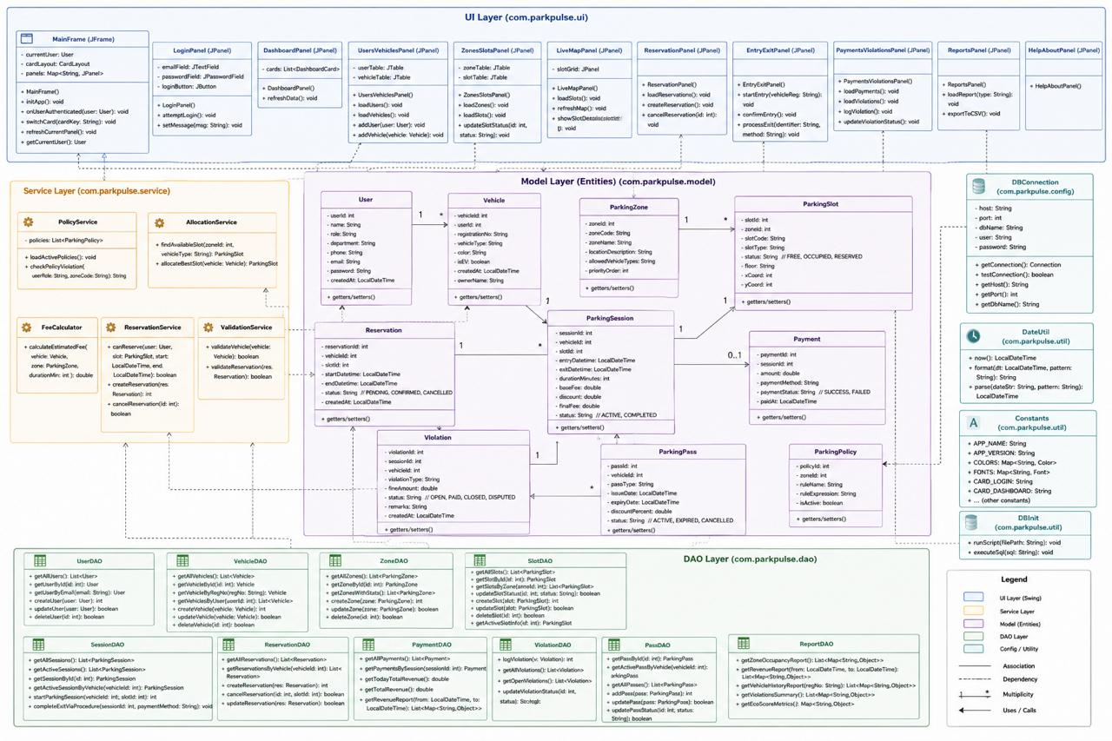

Use Case Diagram:

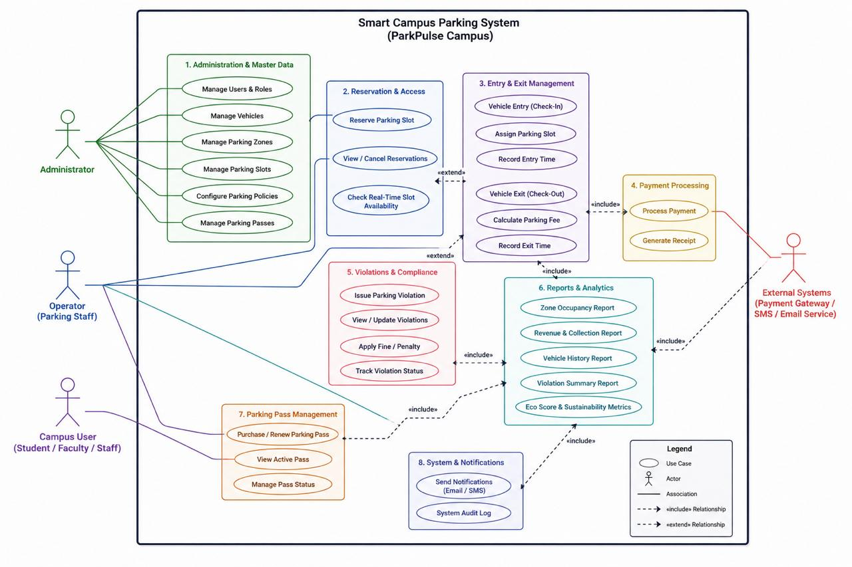

State Diagram:

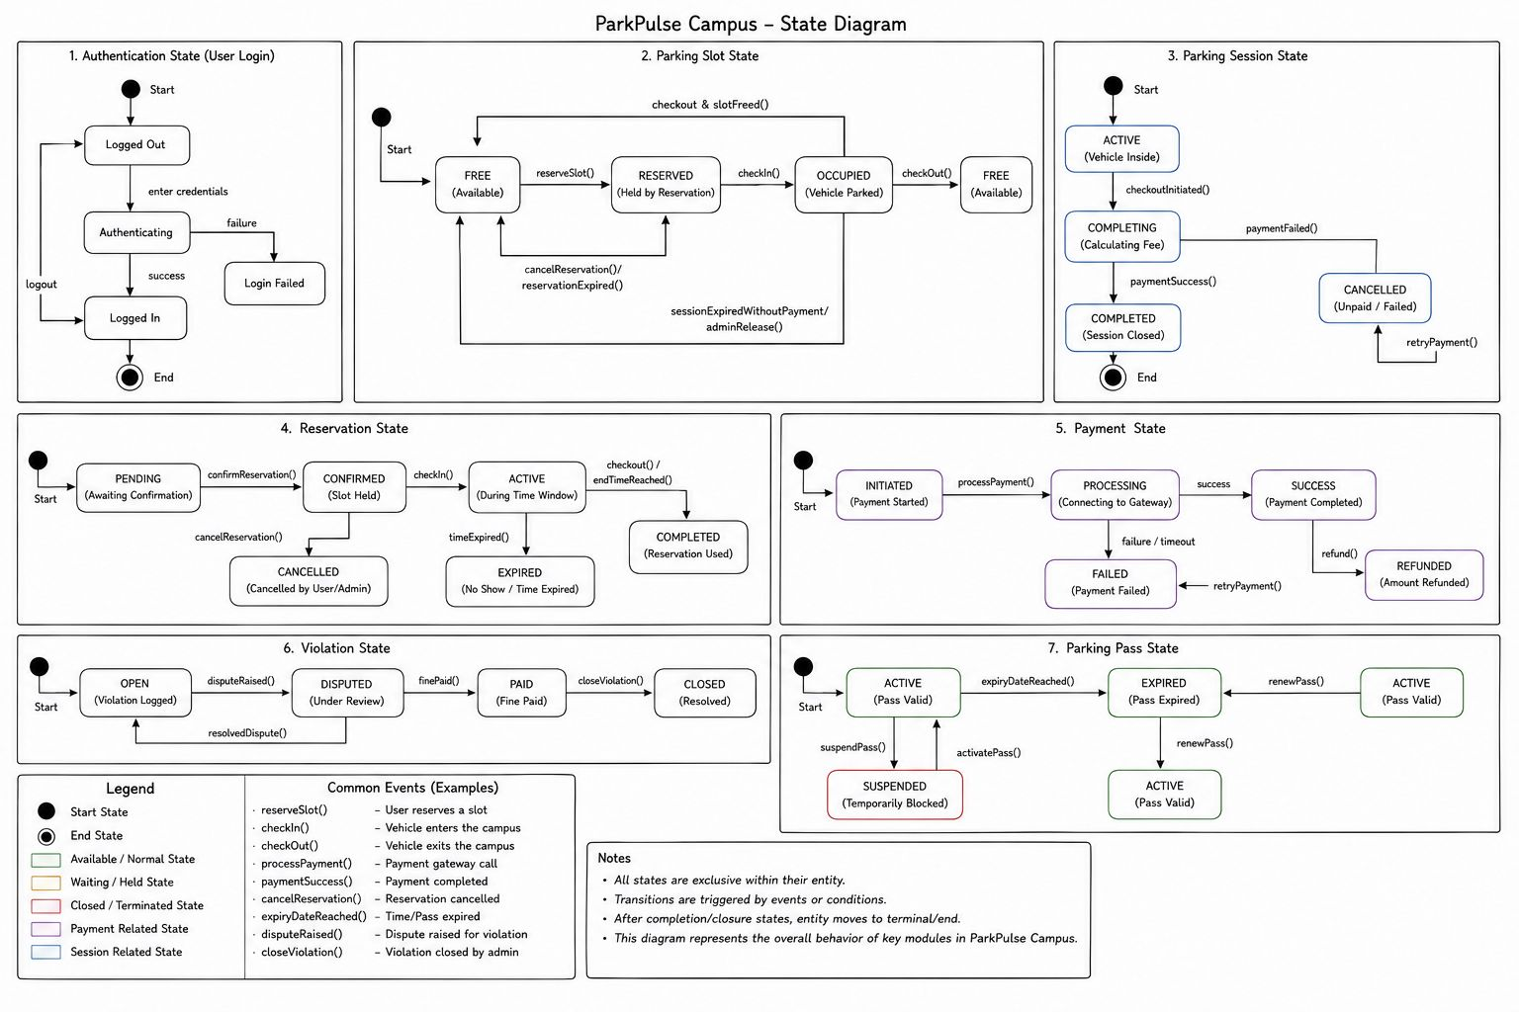

Source Code:
Table Creation:

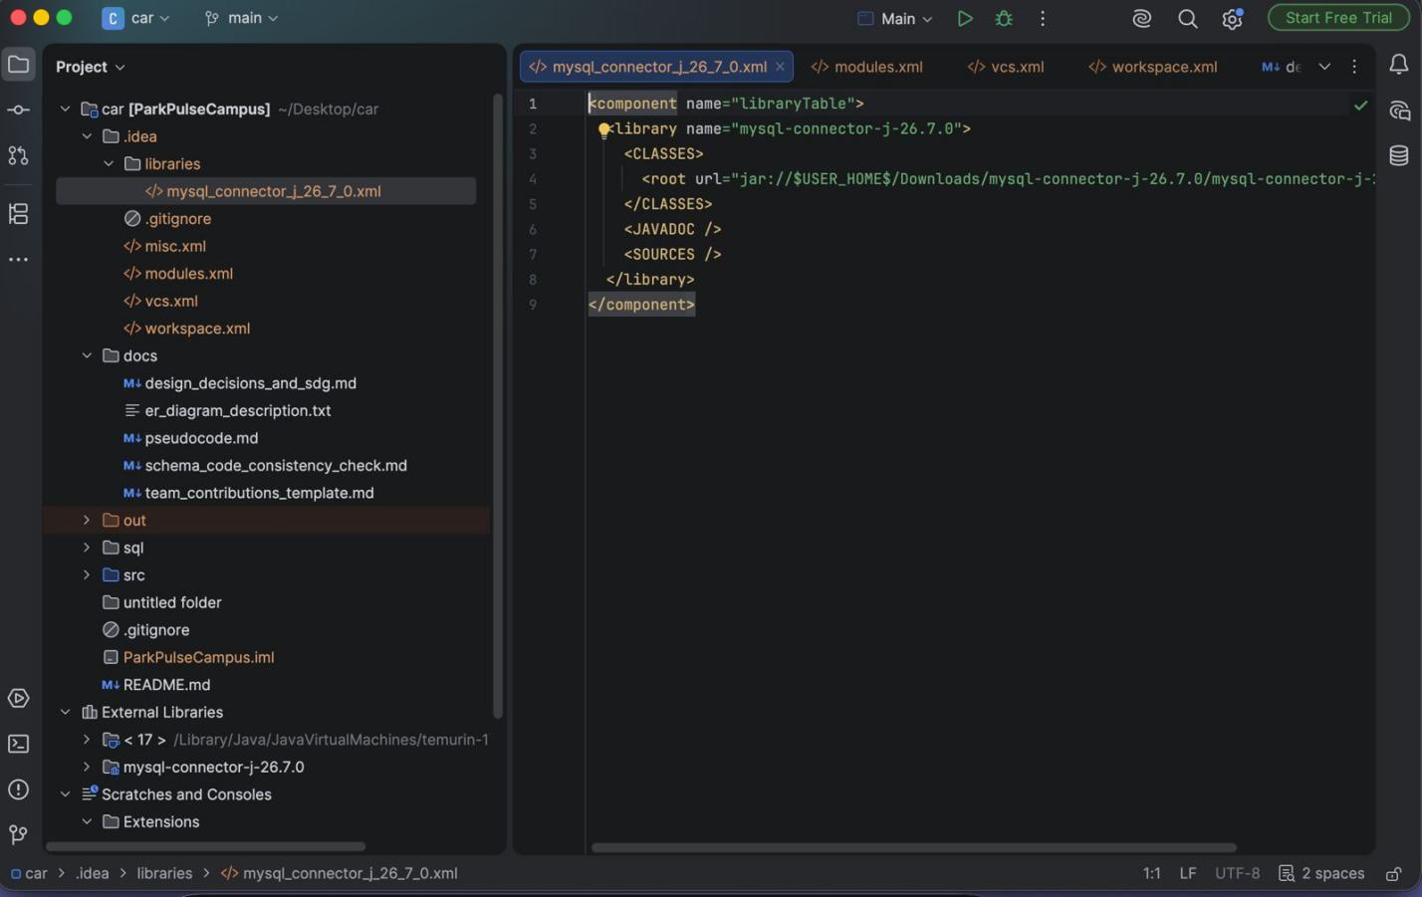

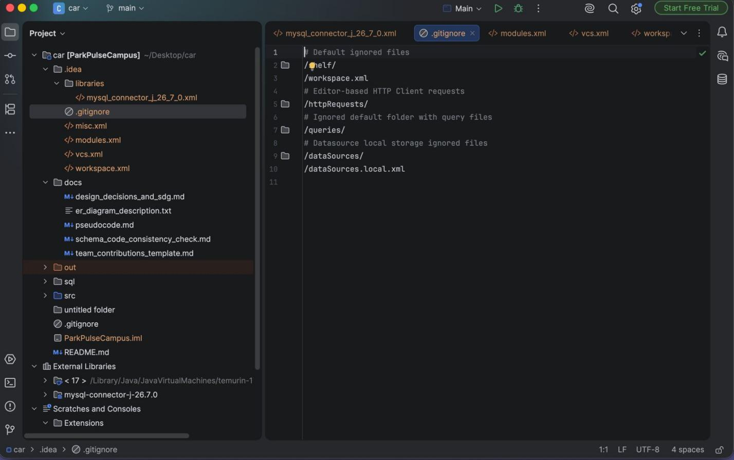

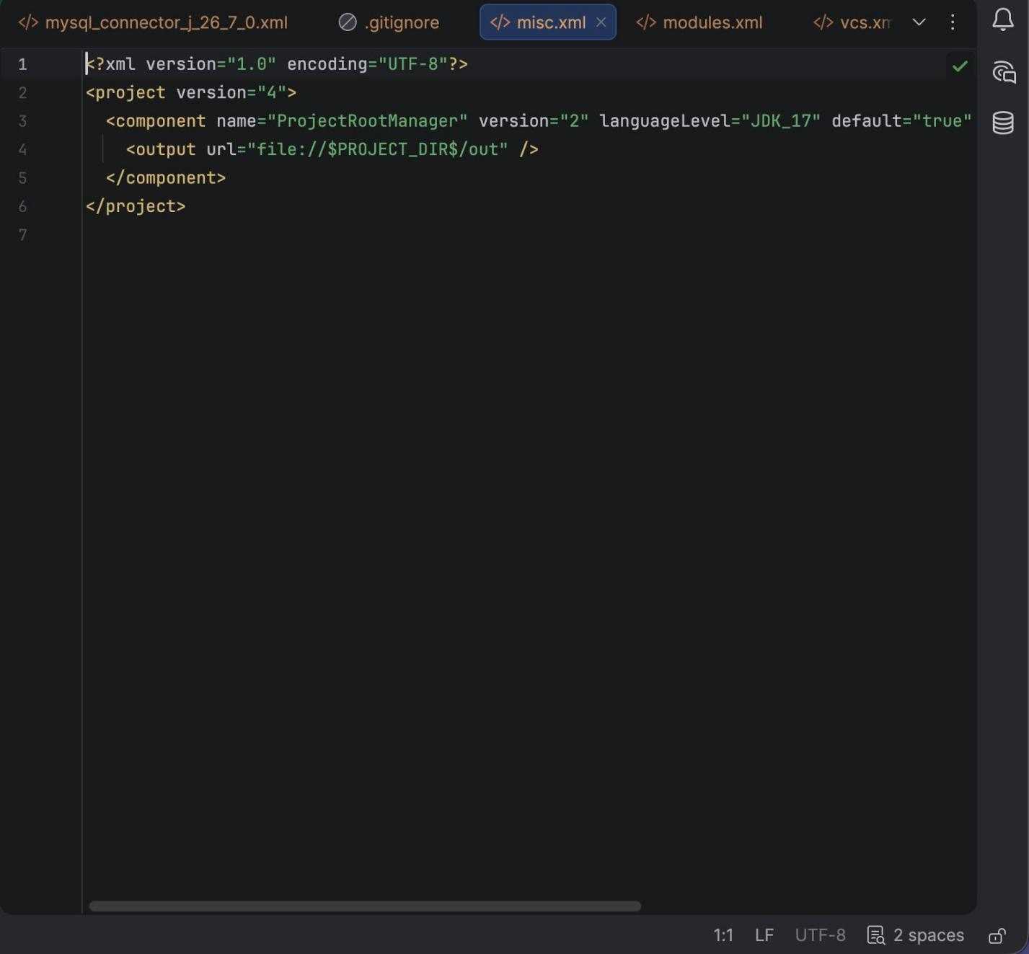

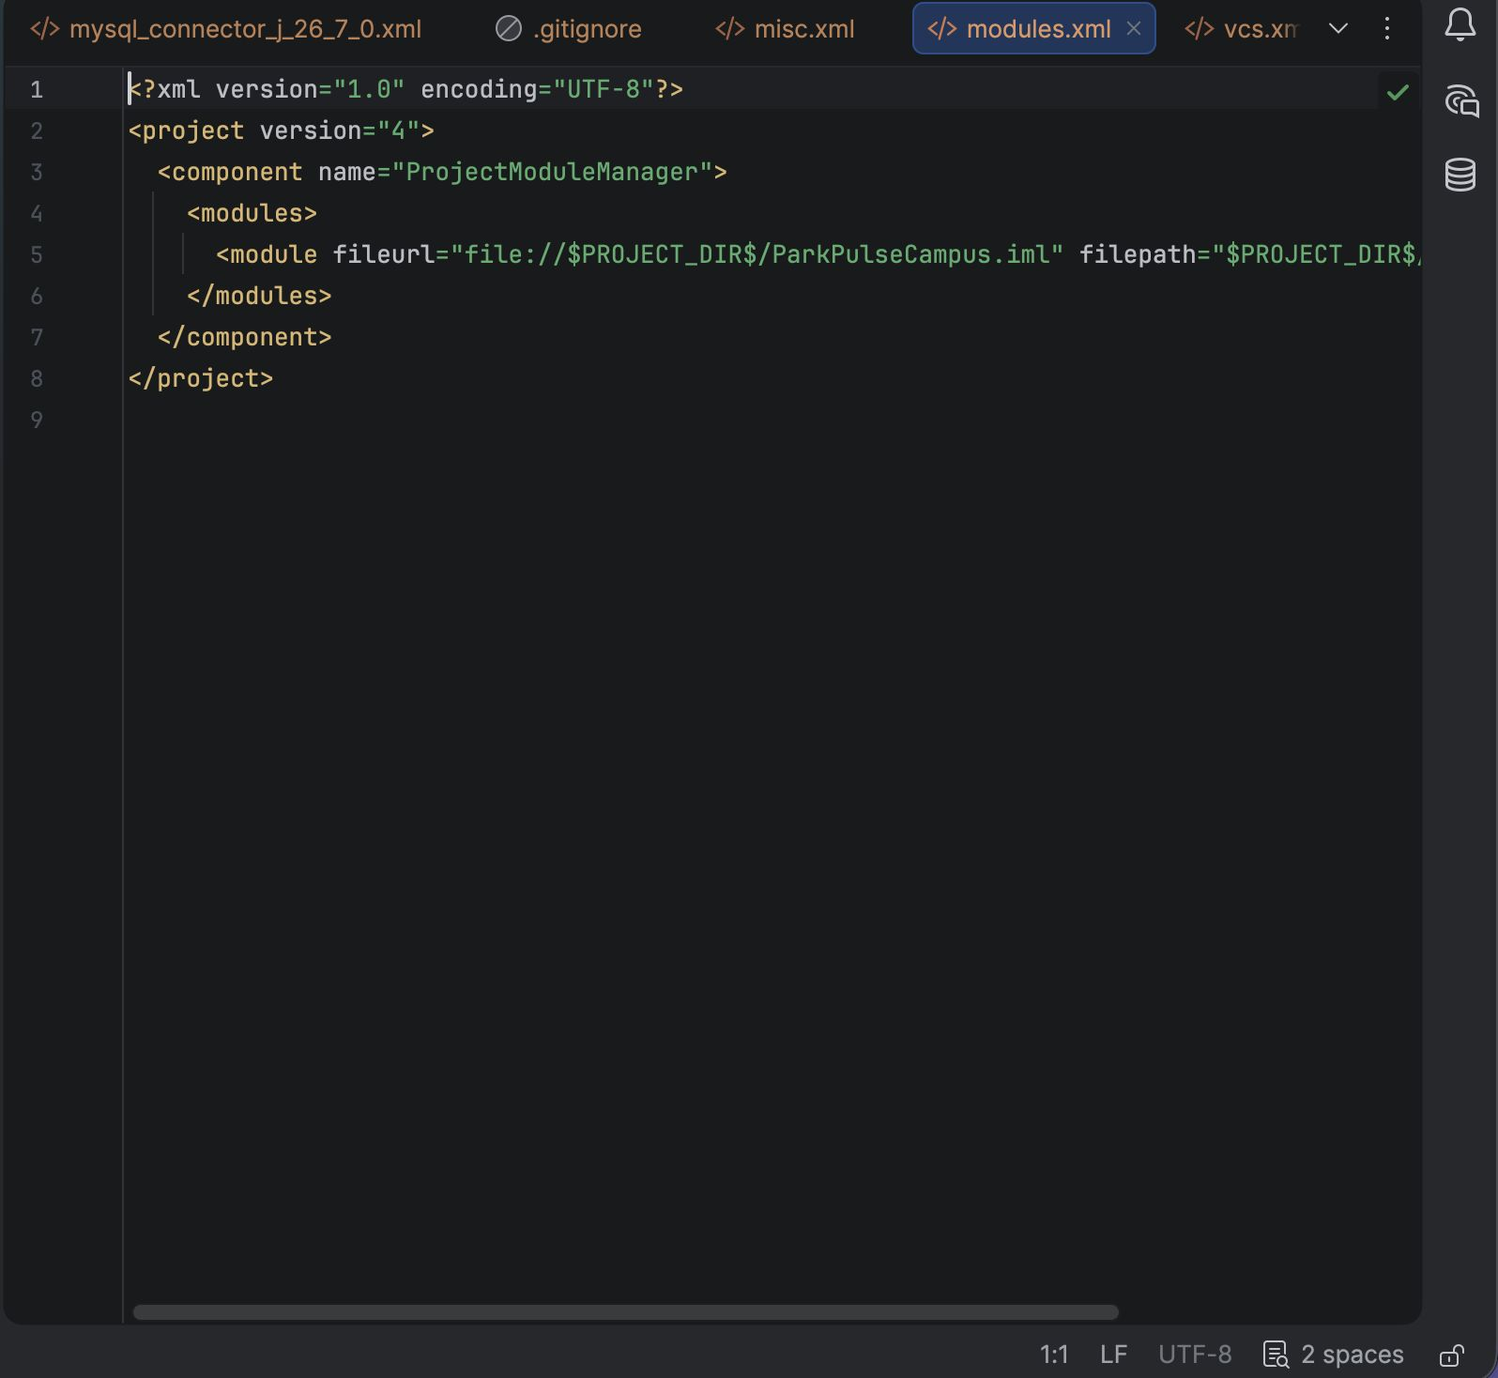



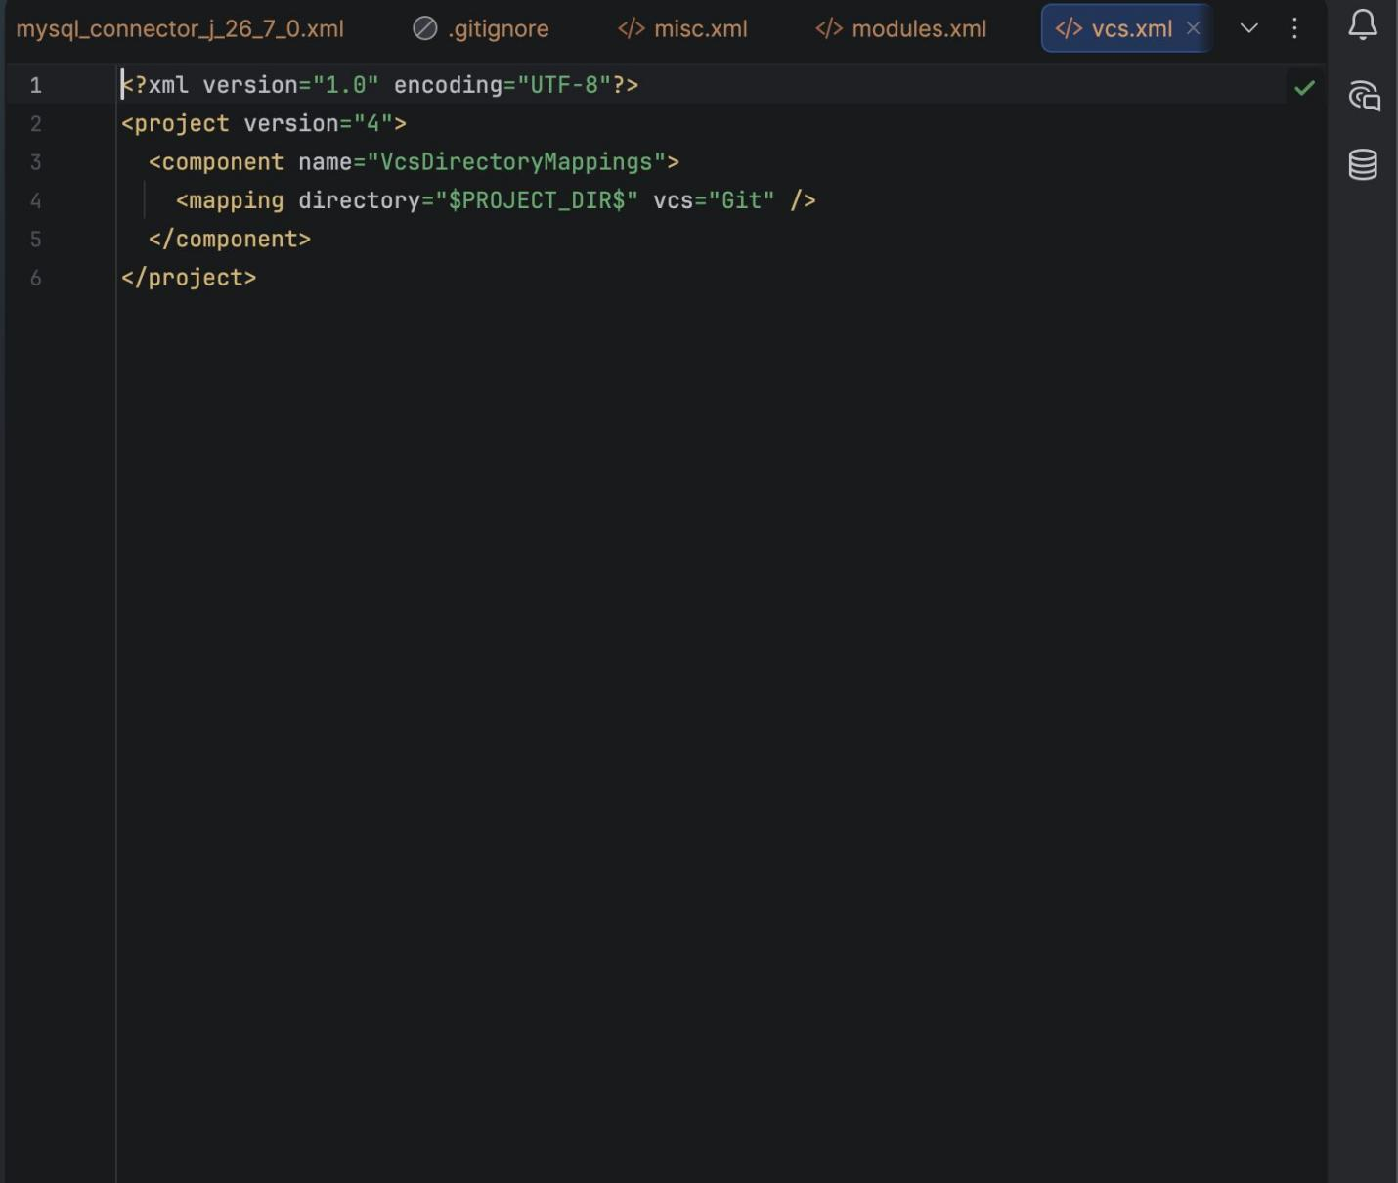

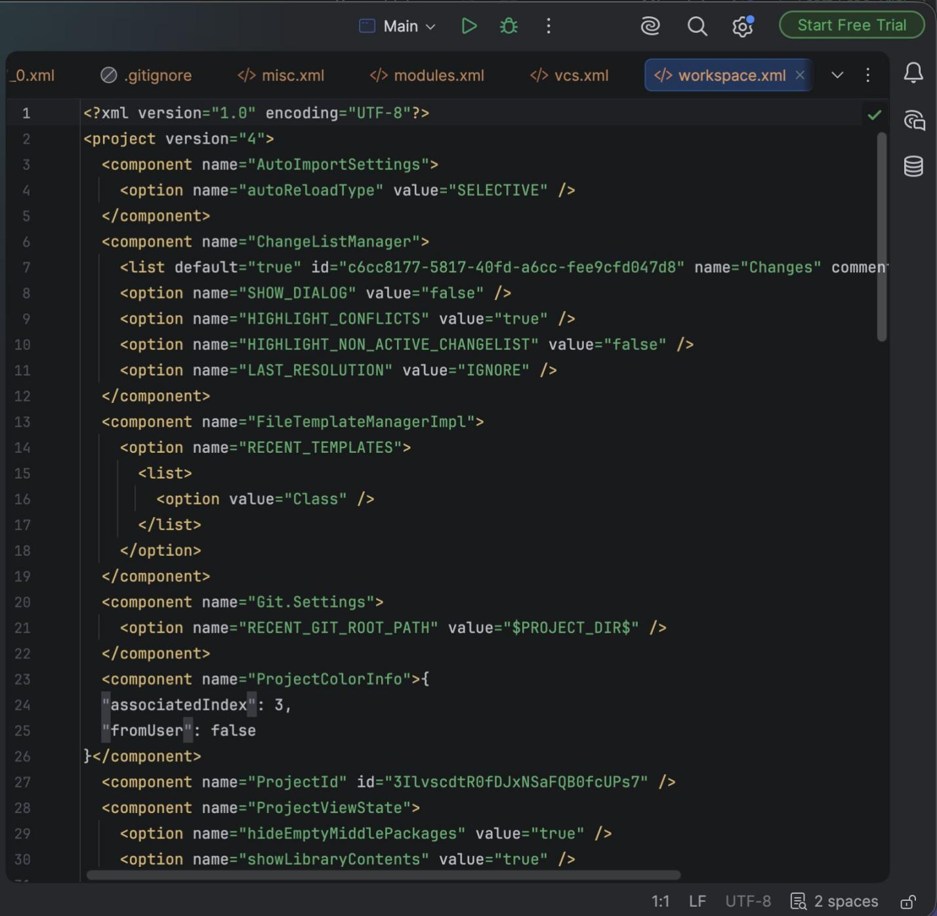

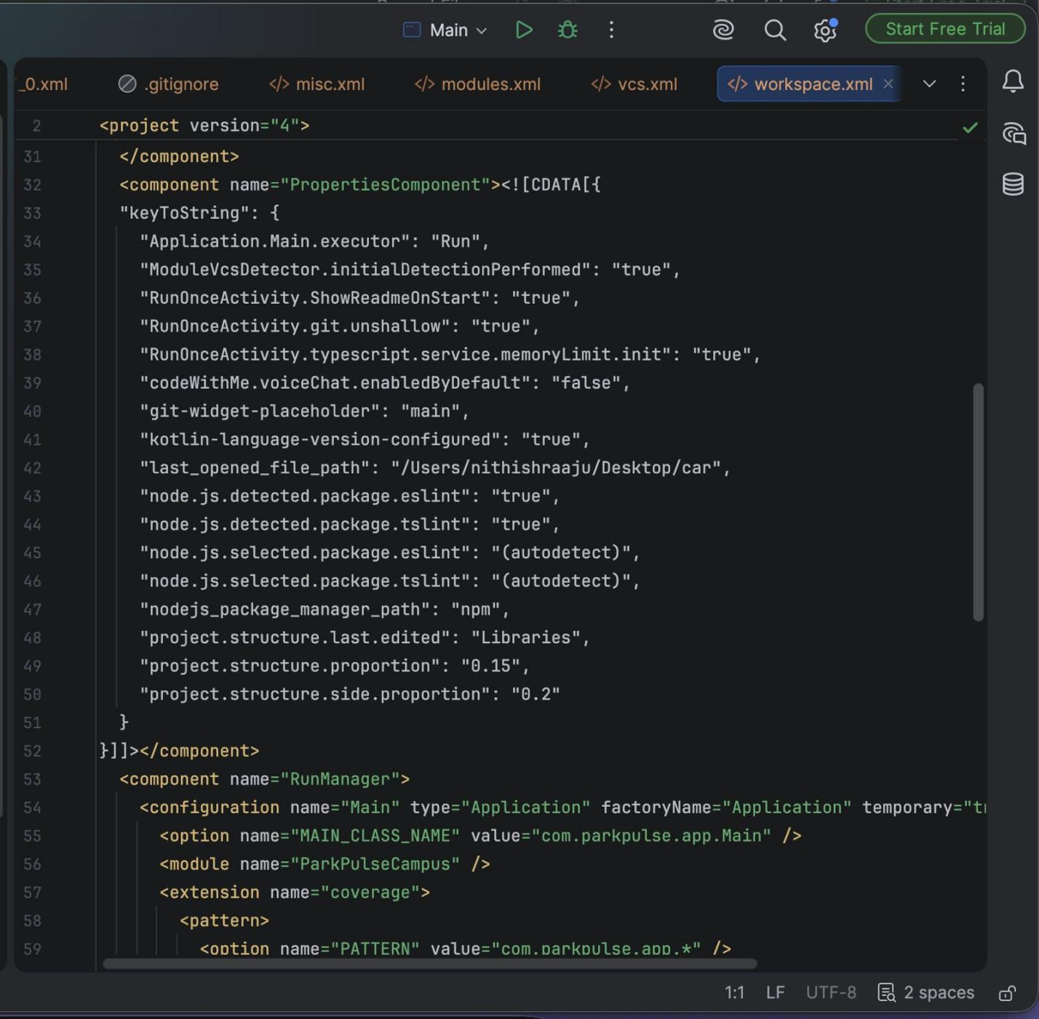

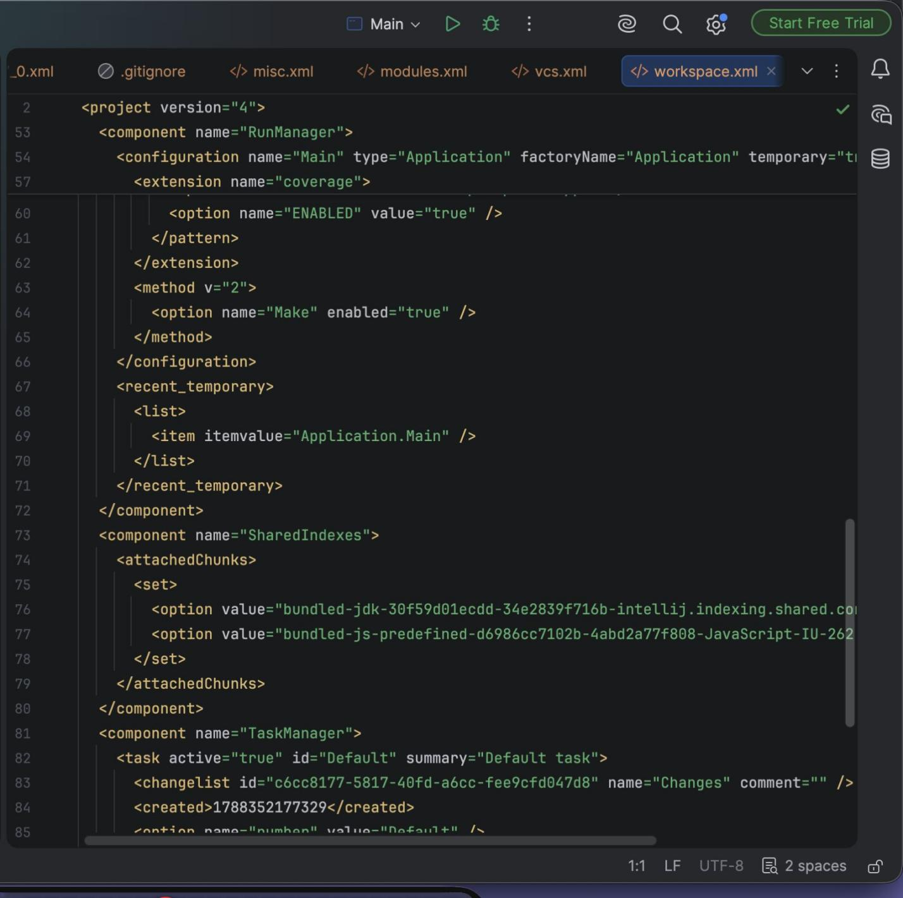

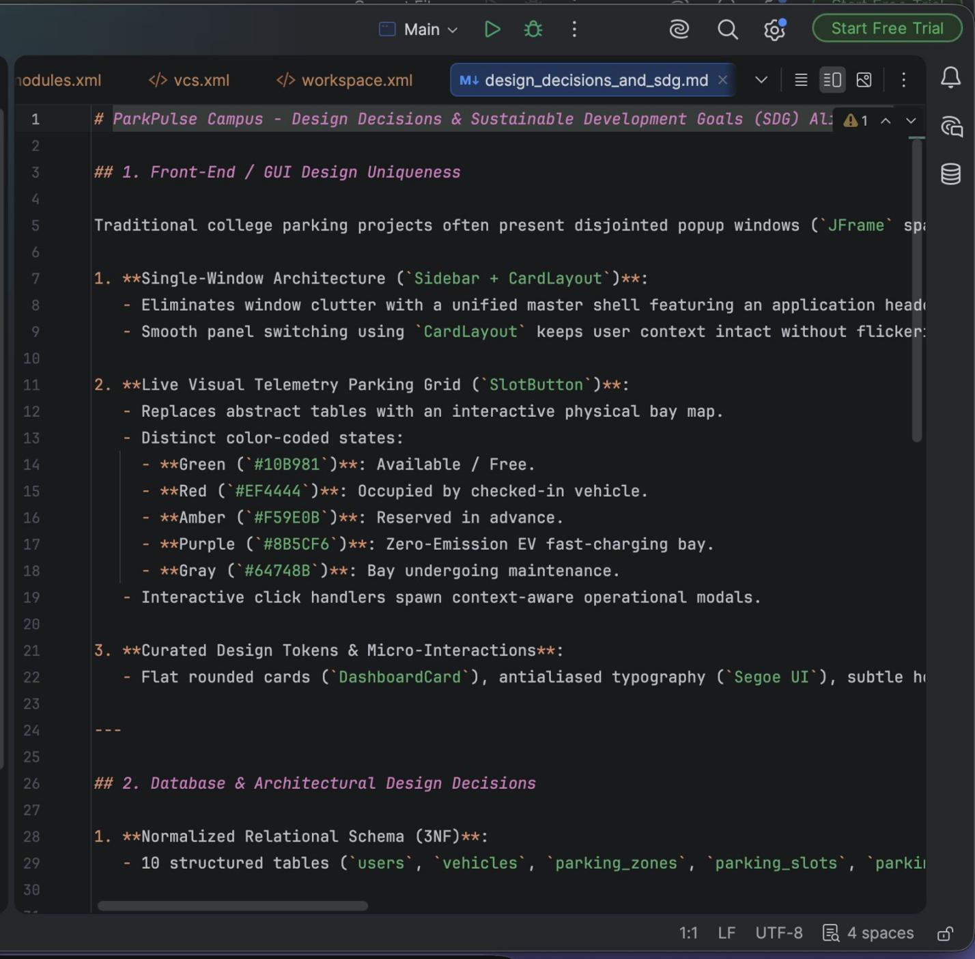

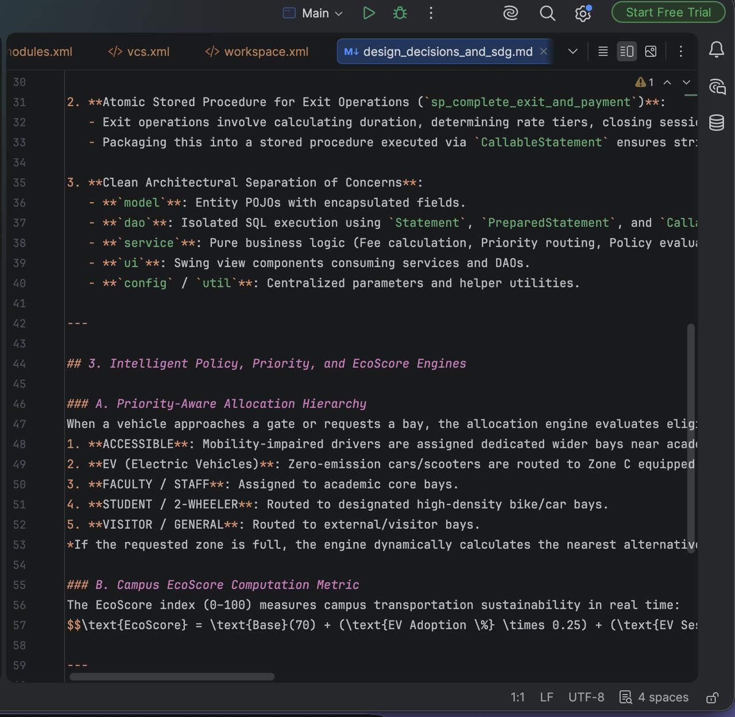

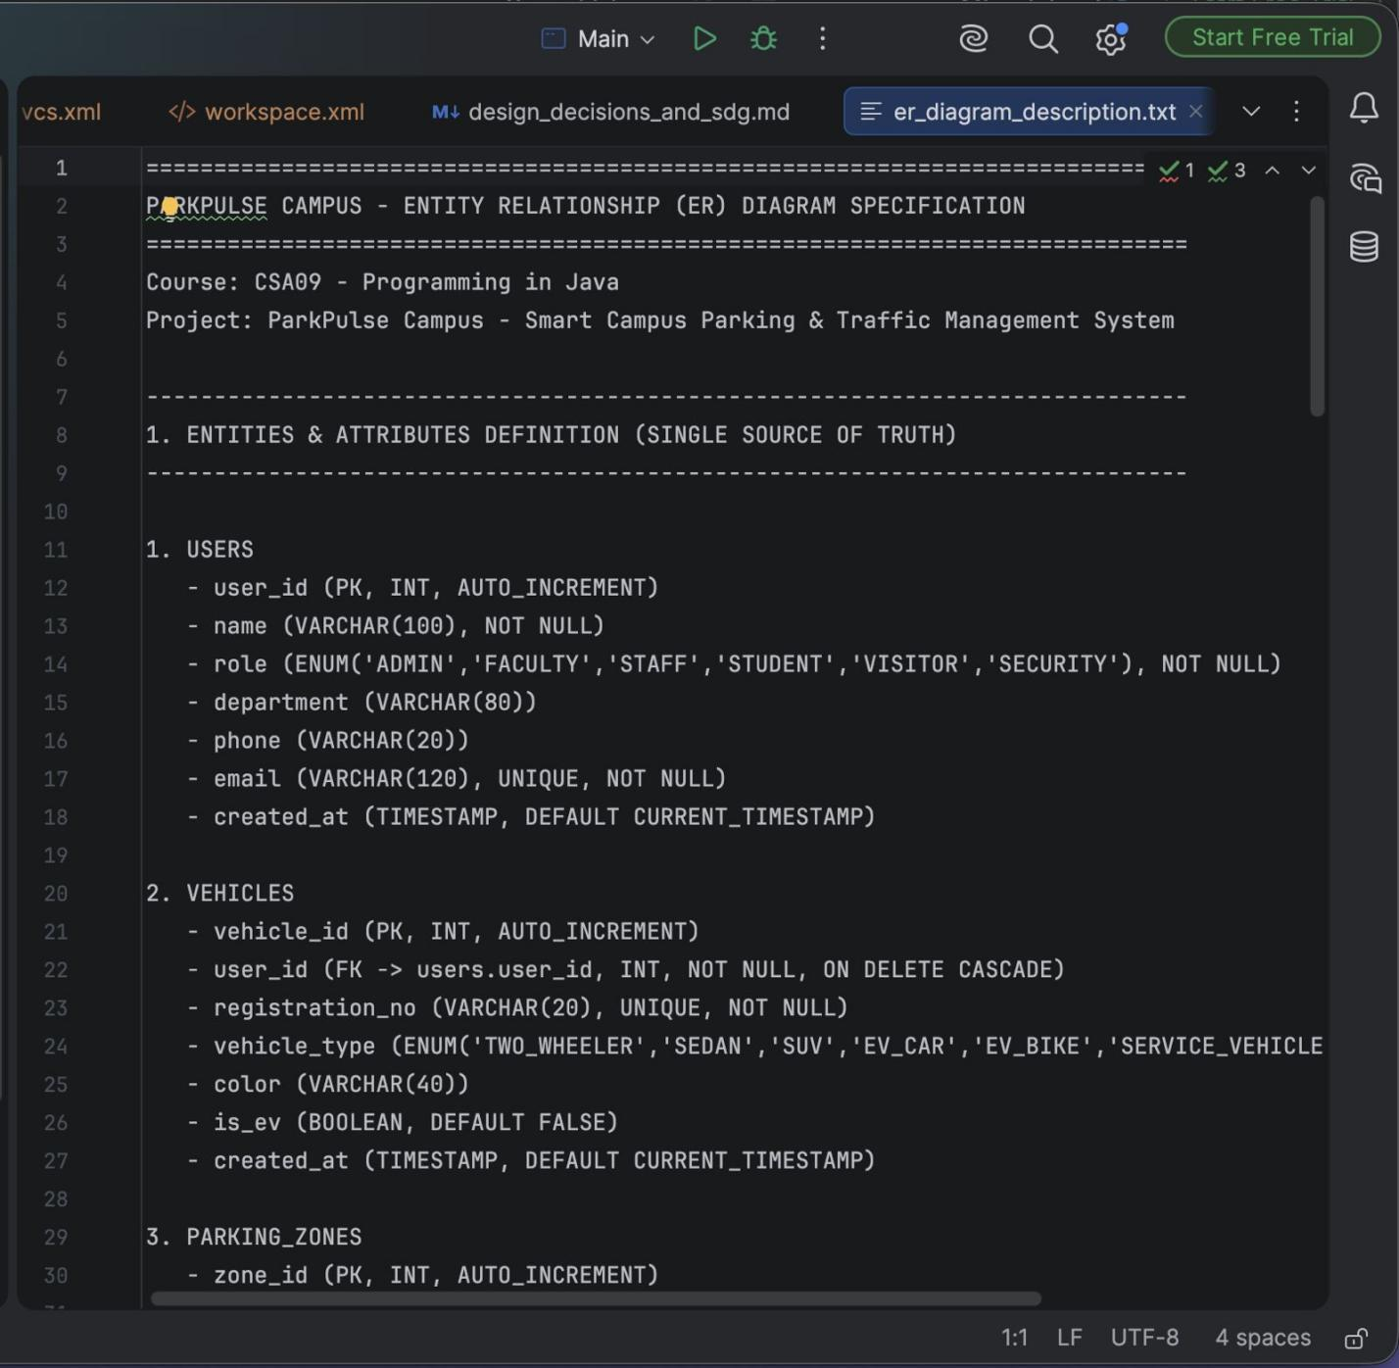

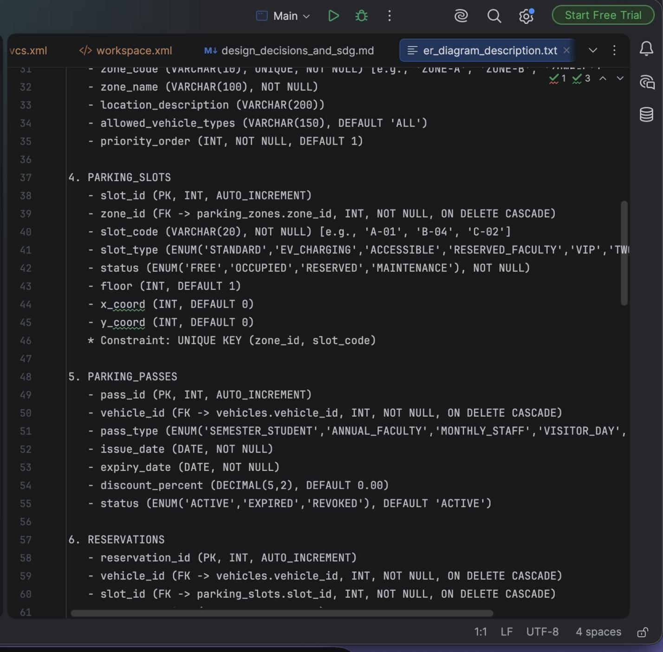

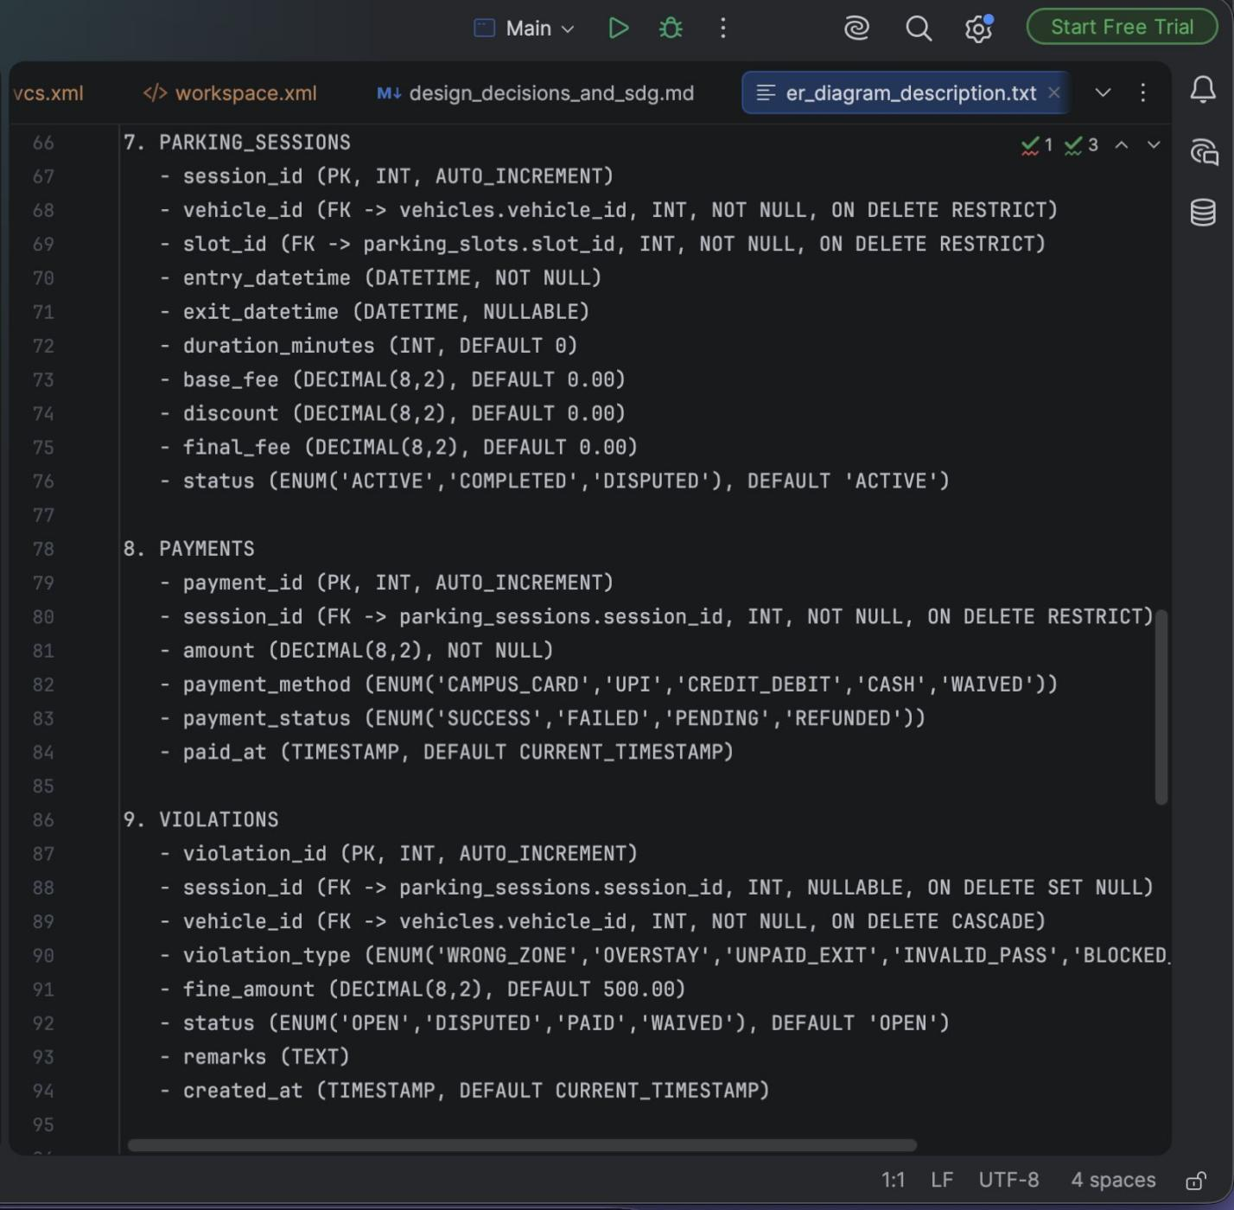

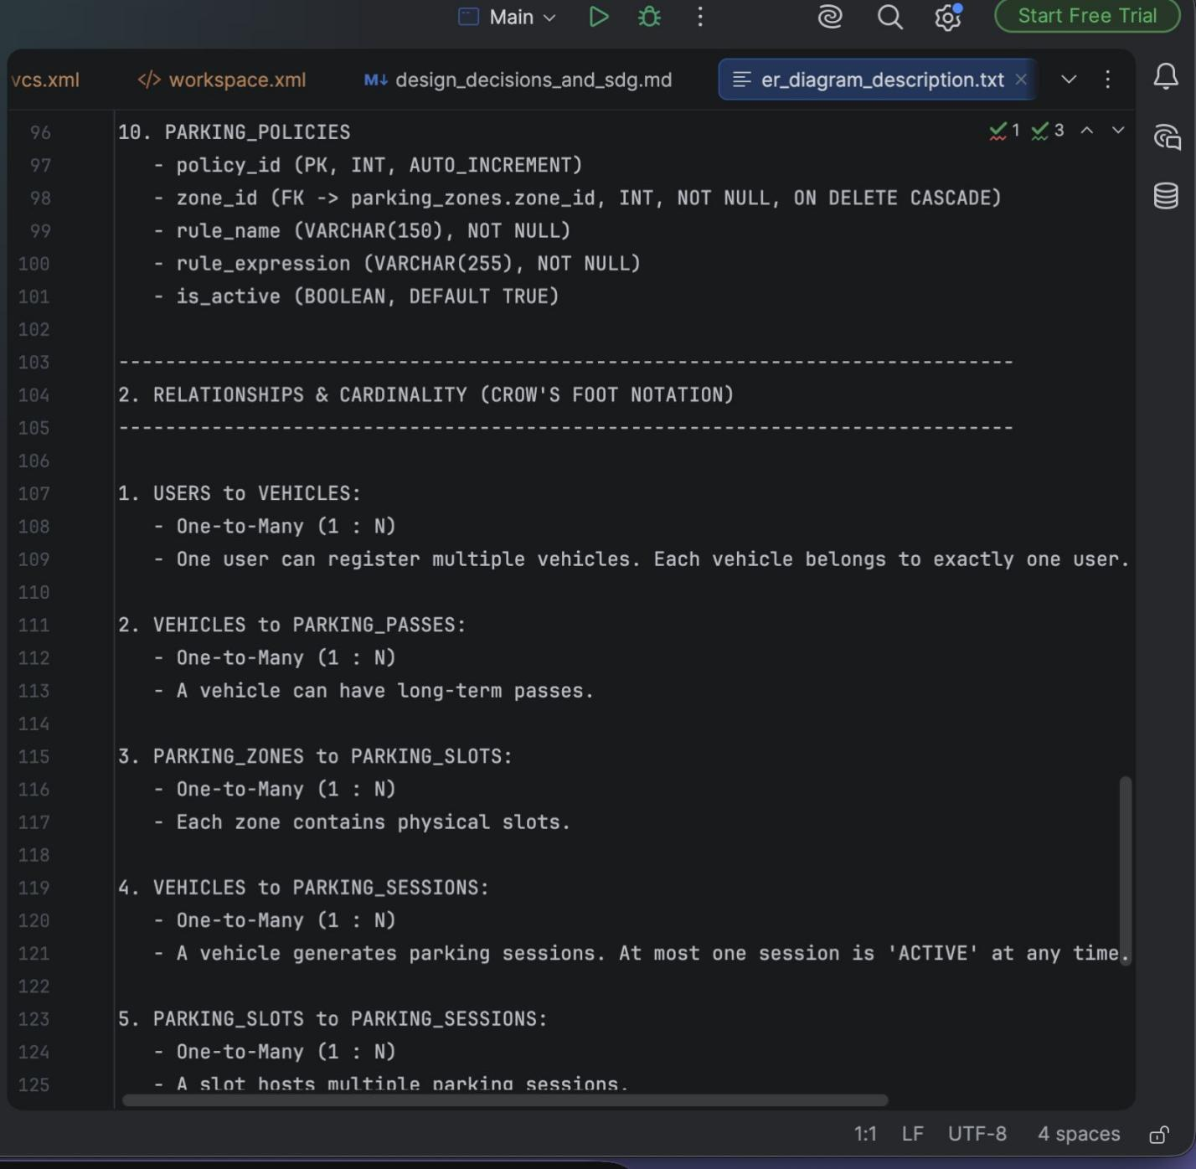

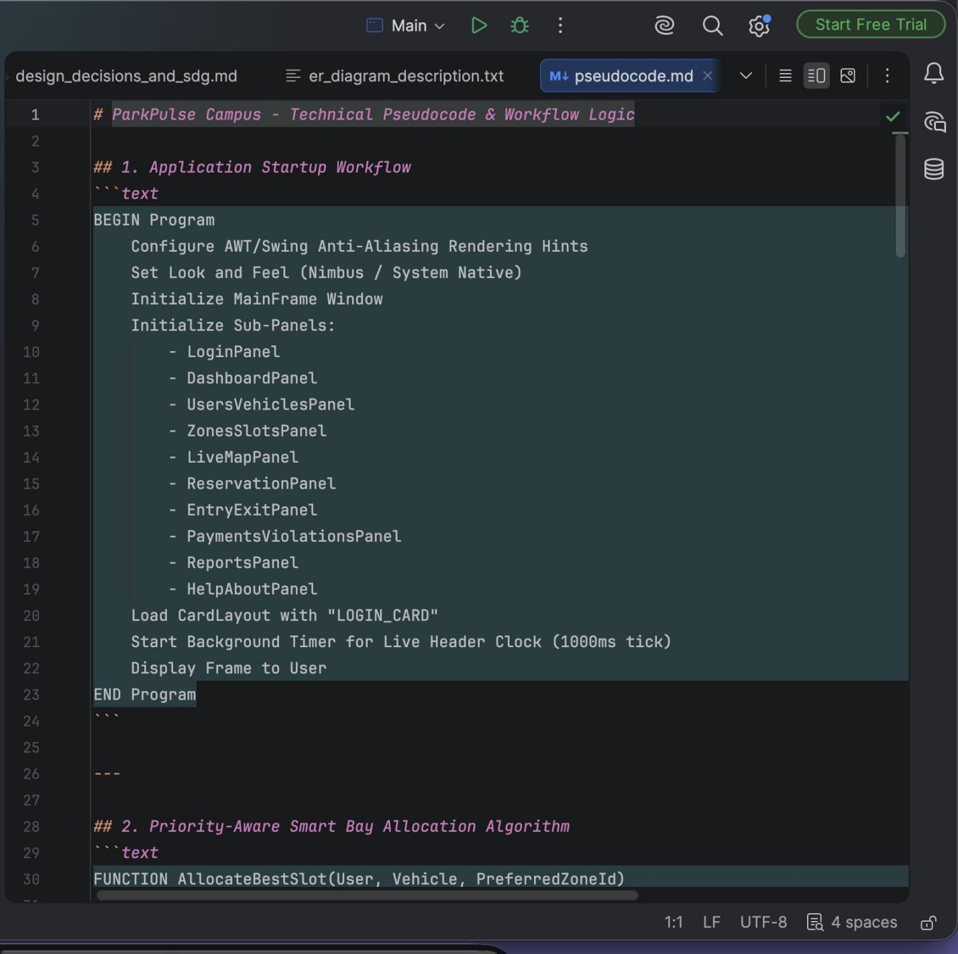

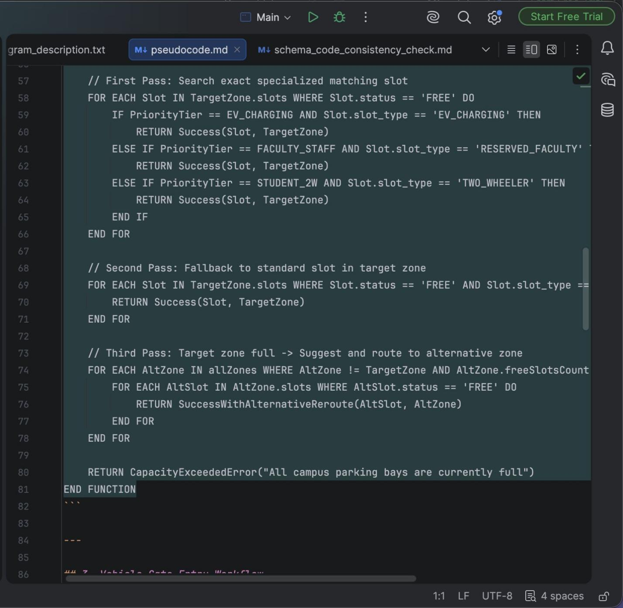

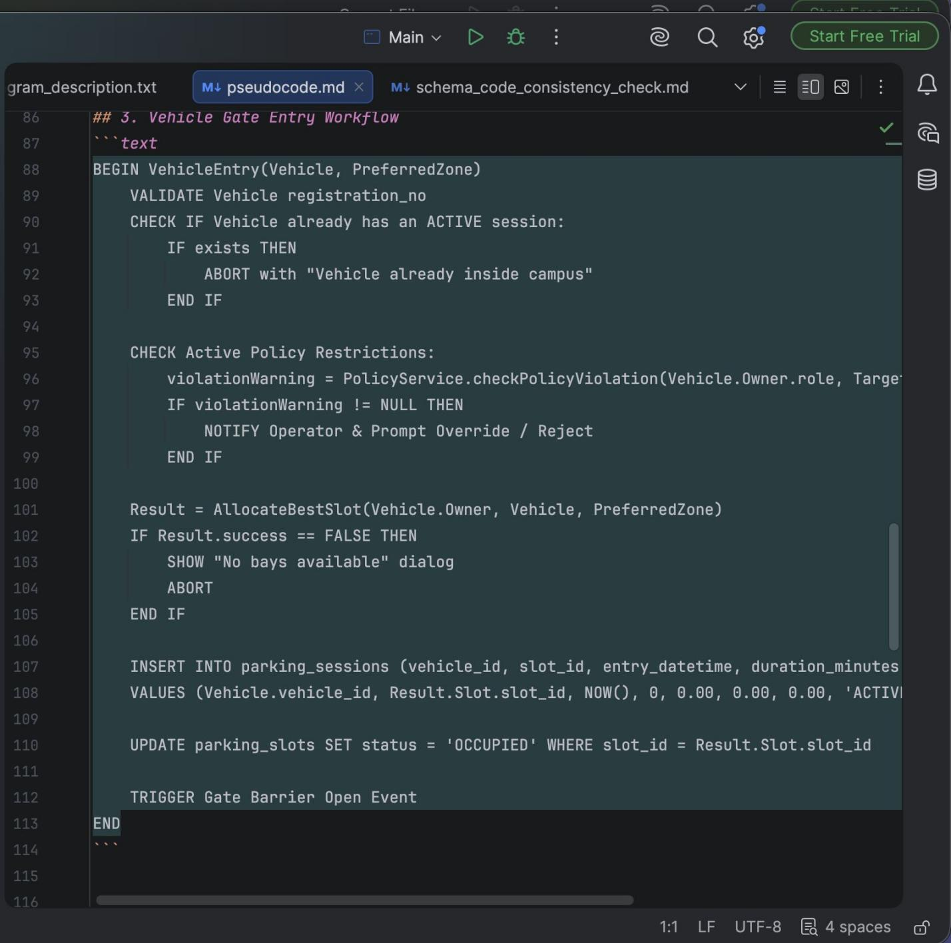

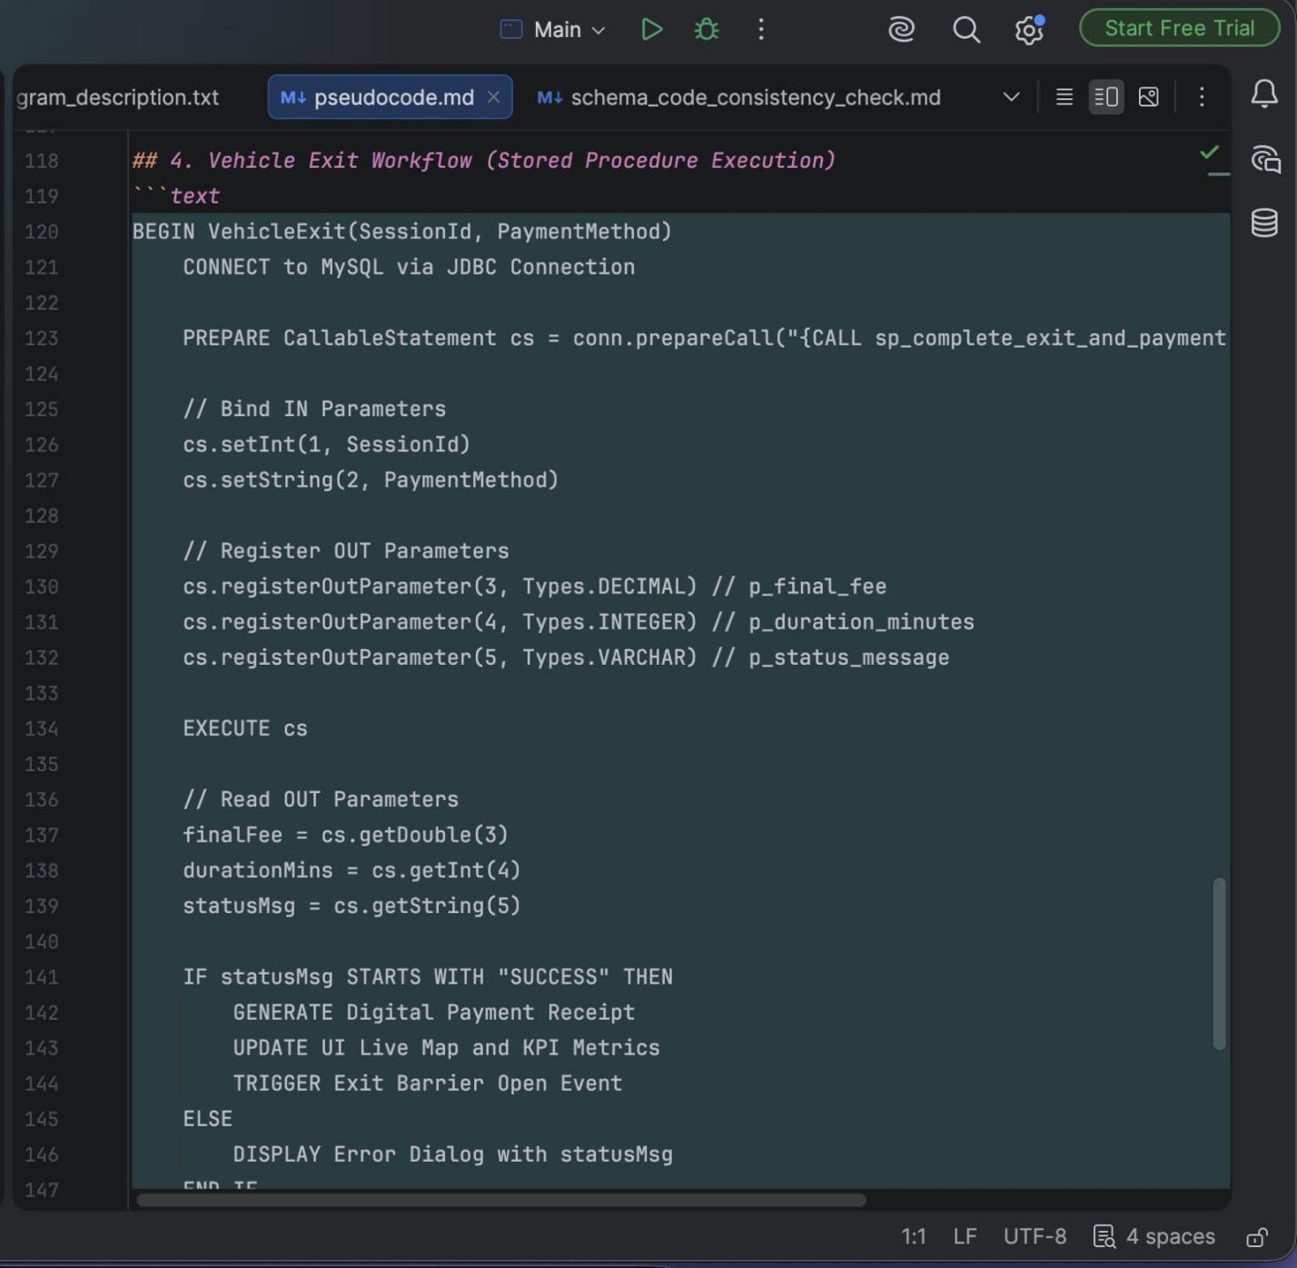

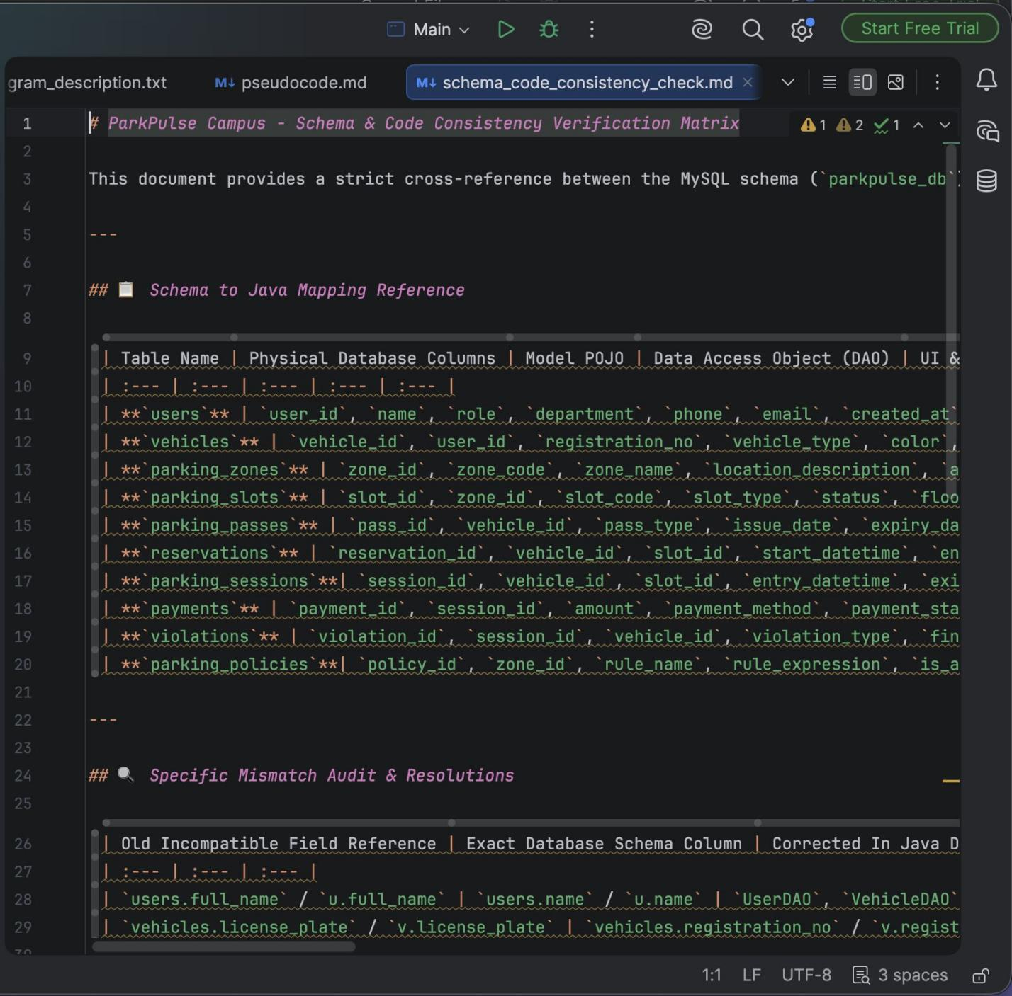

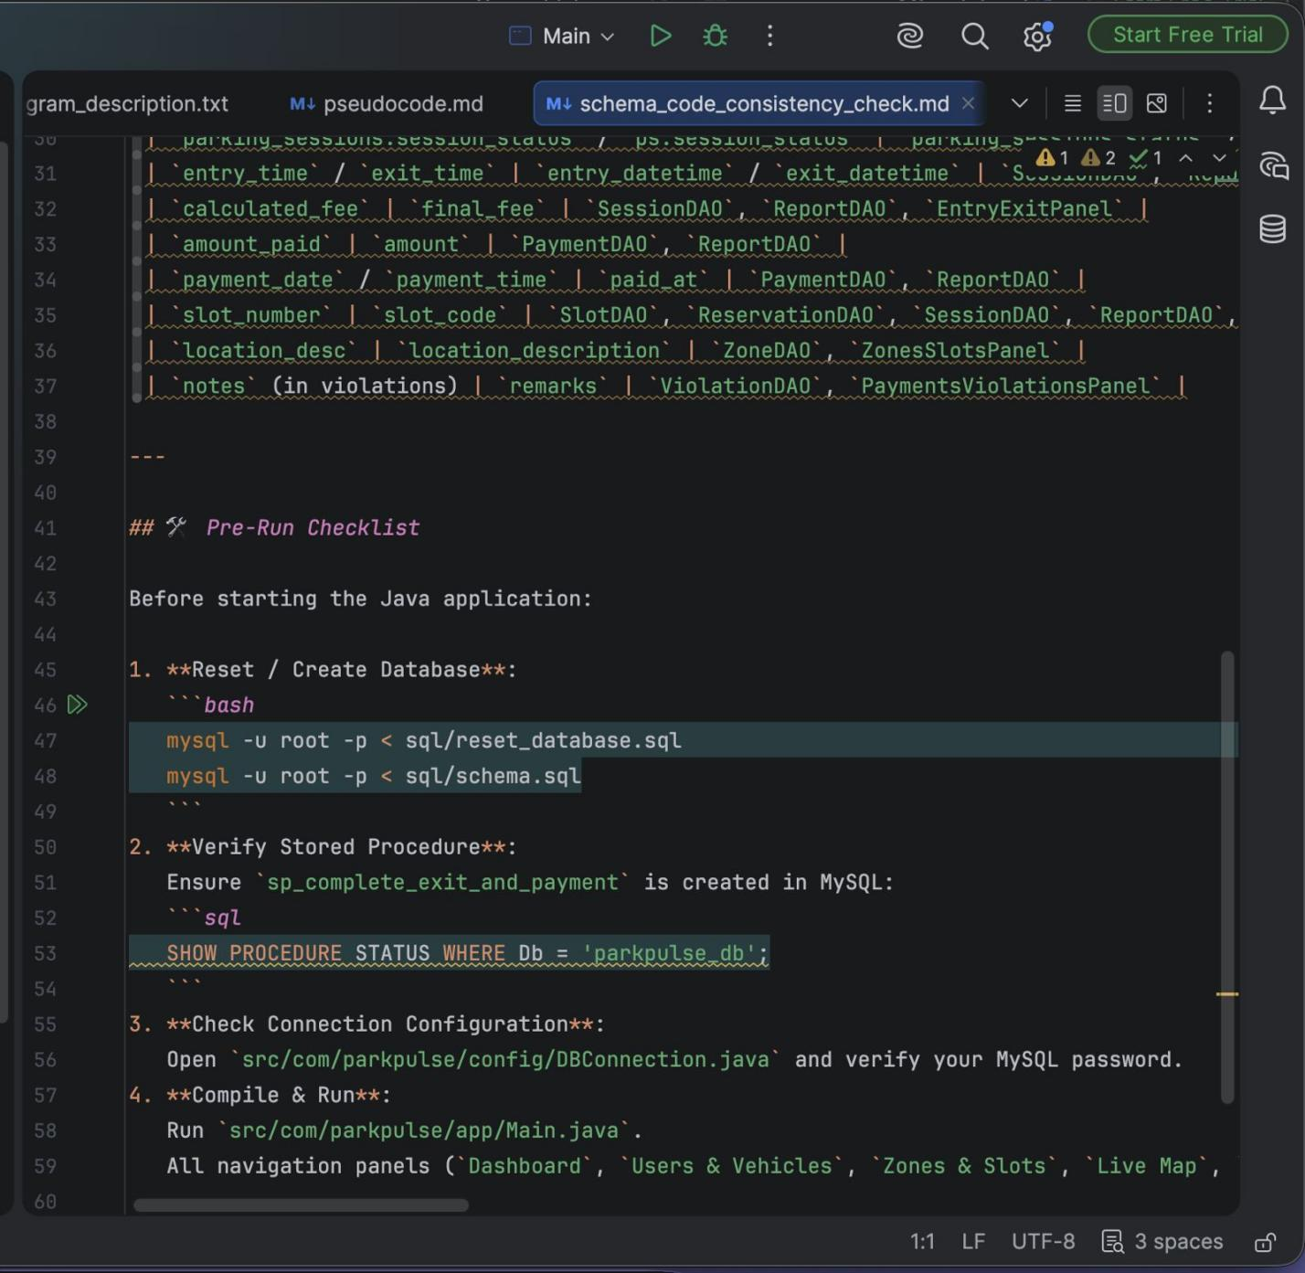

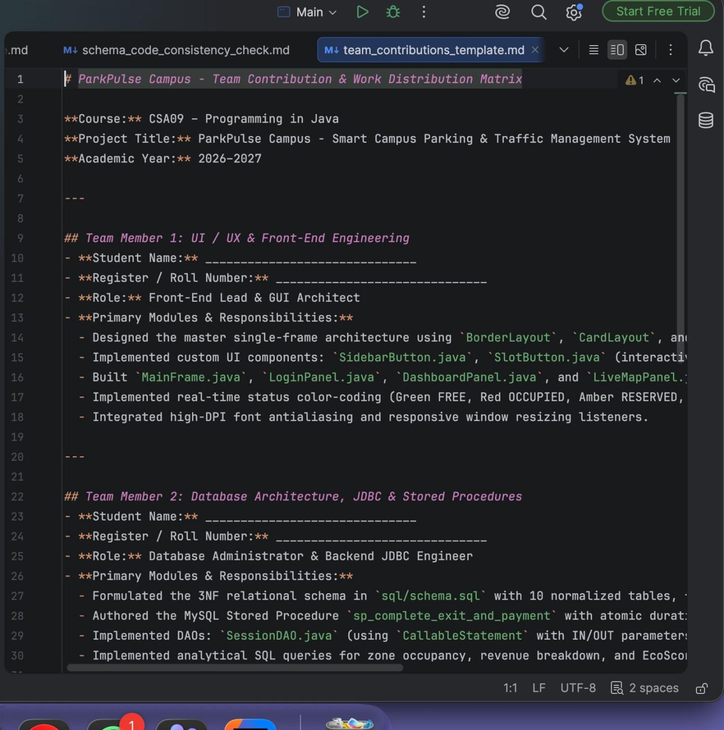

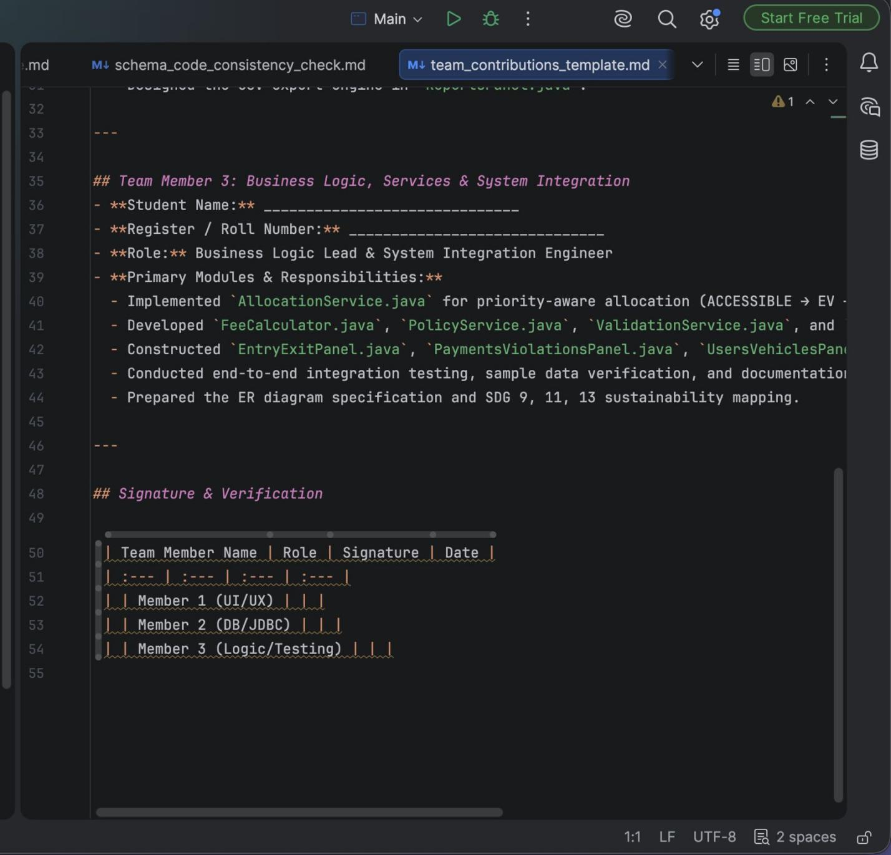

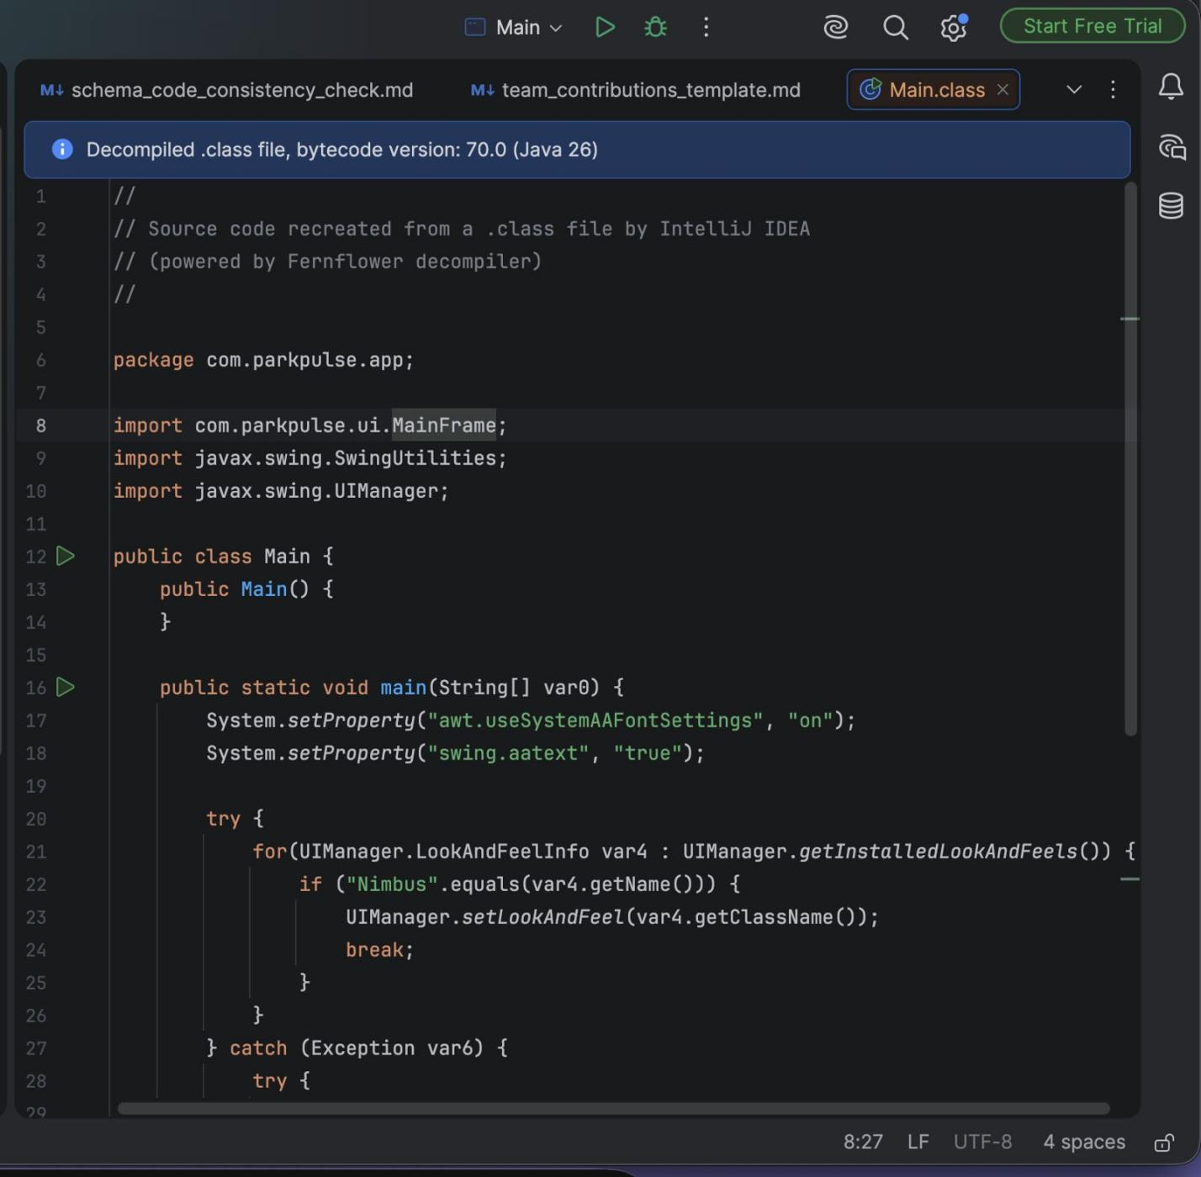

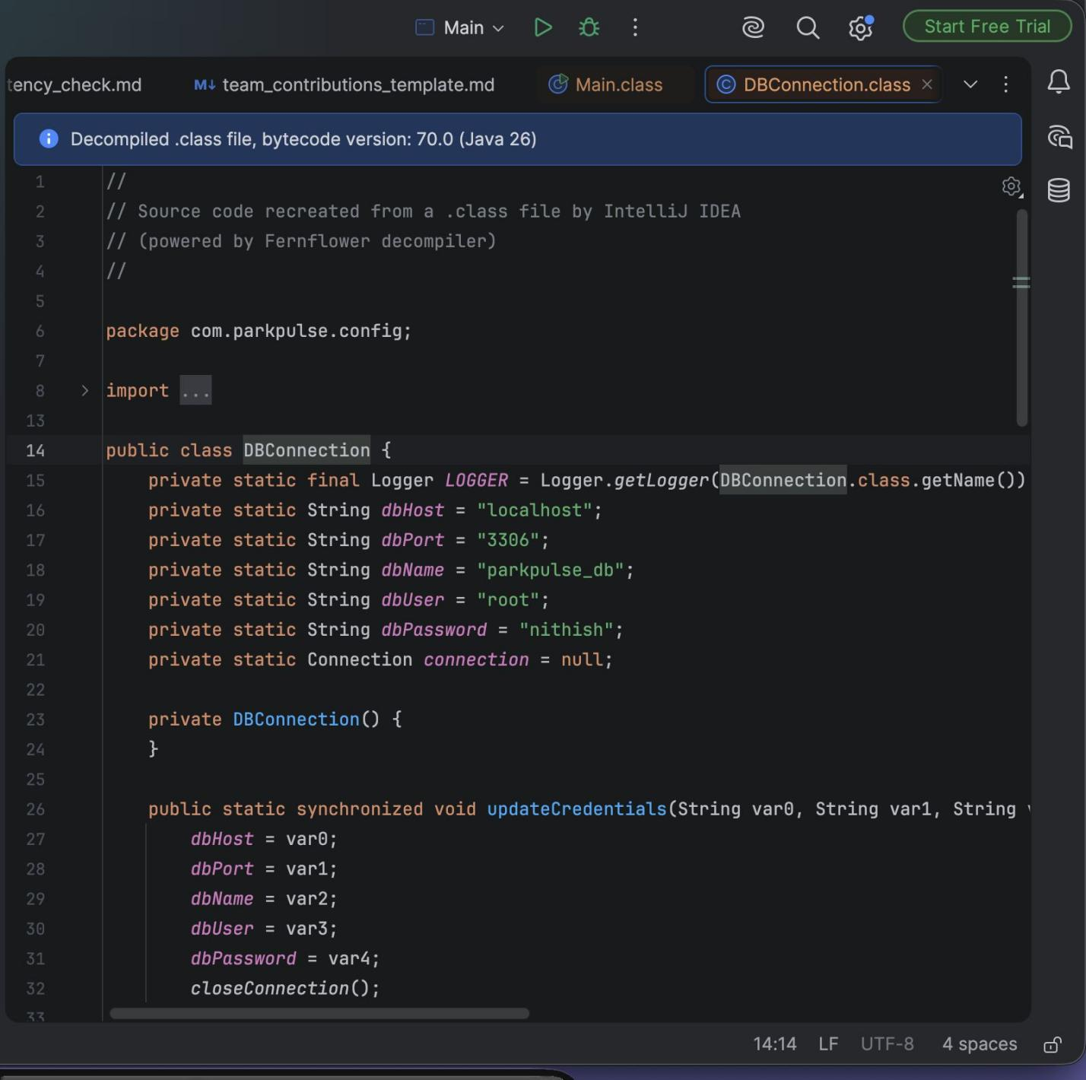

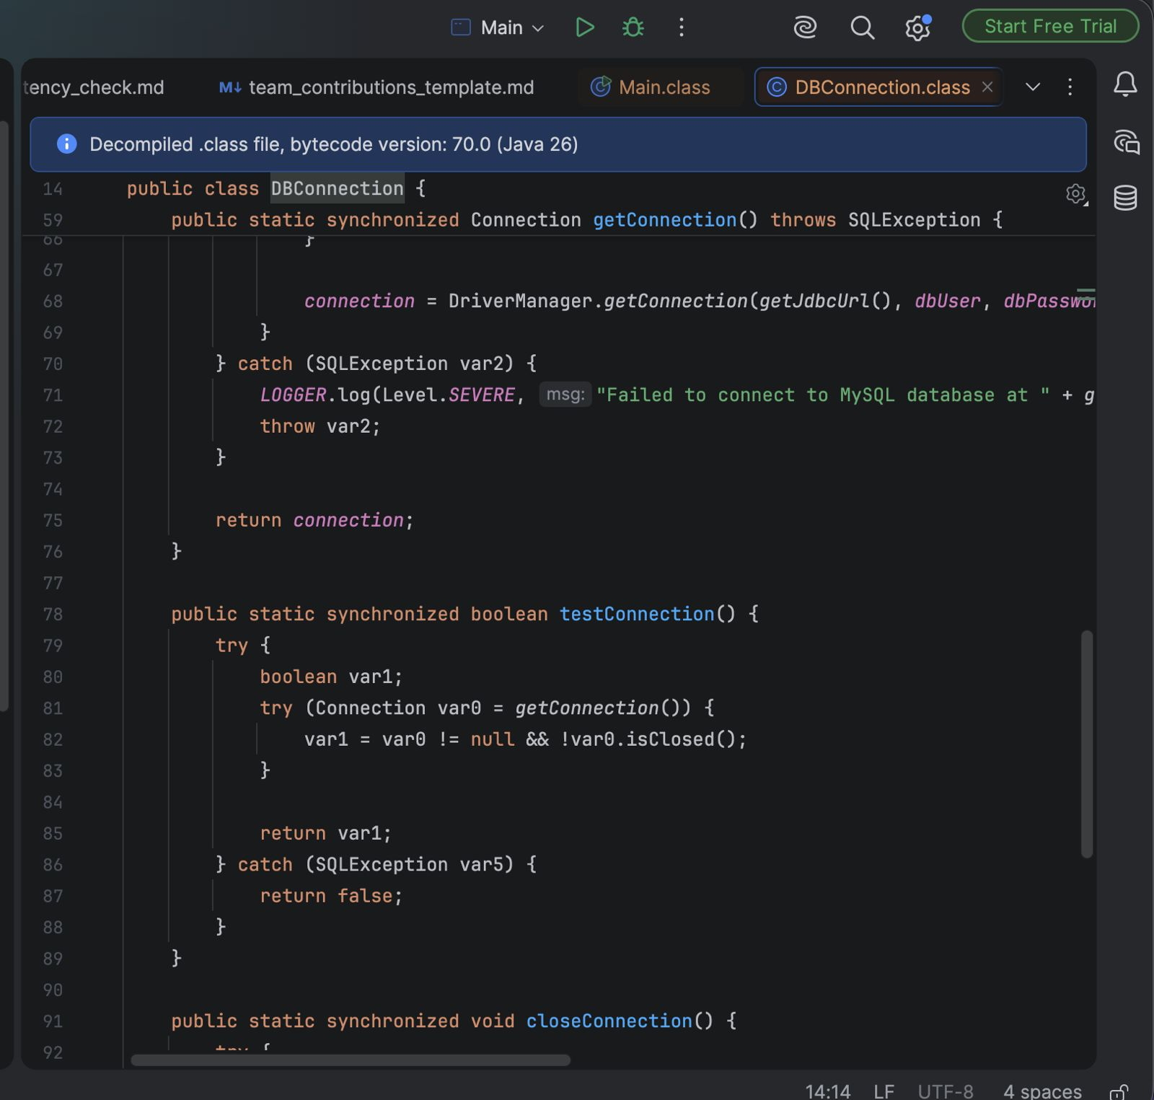



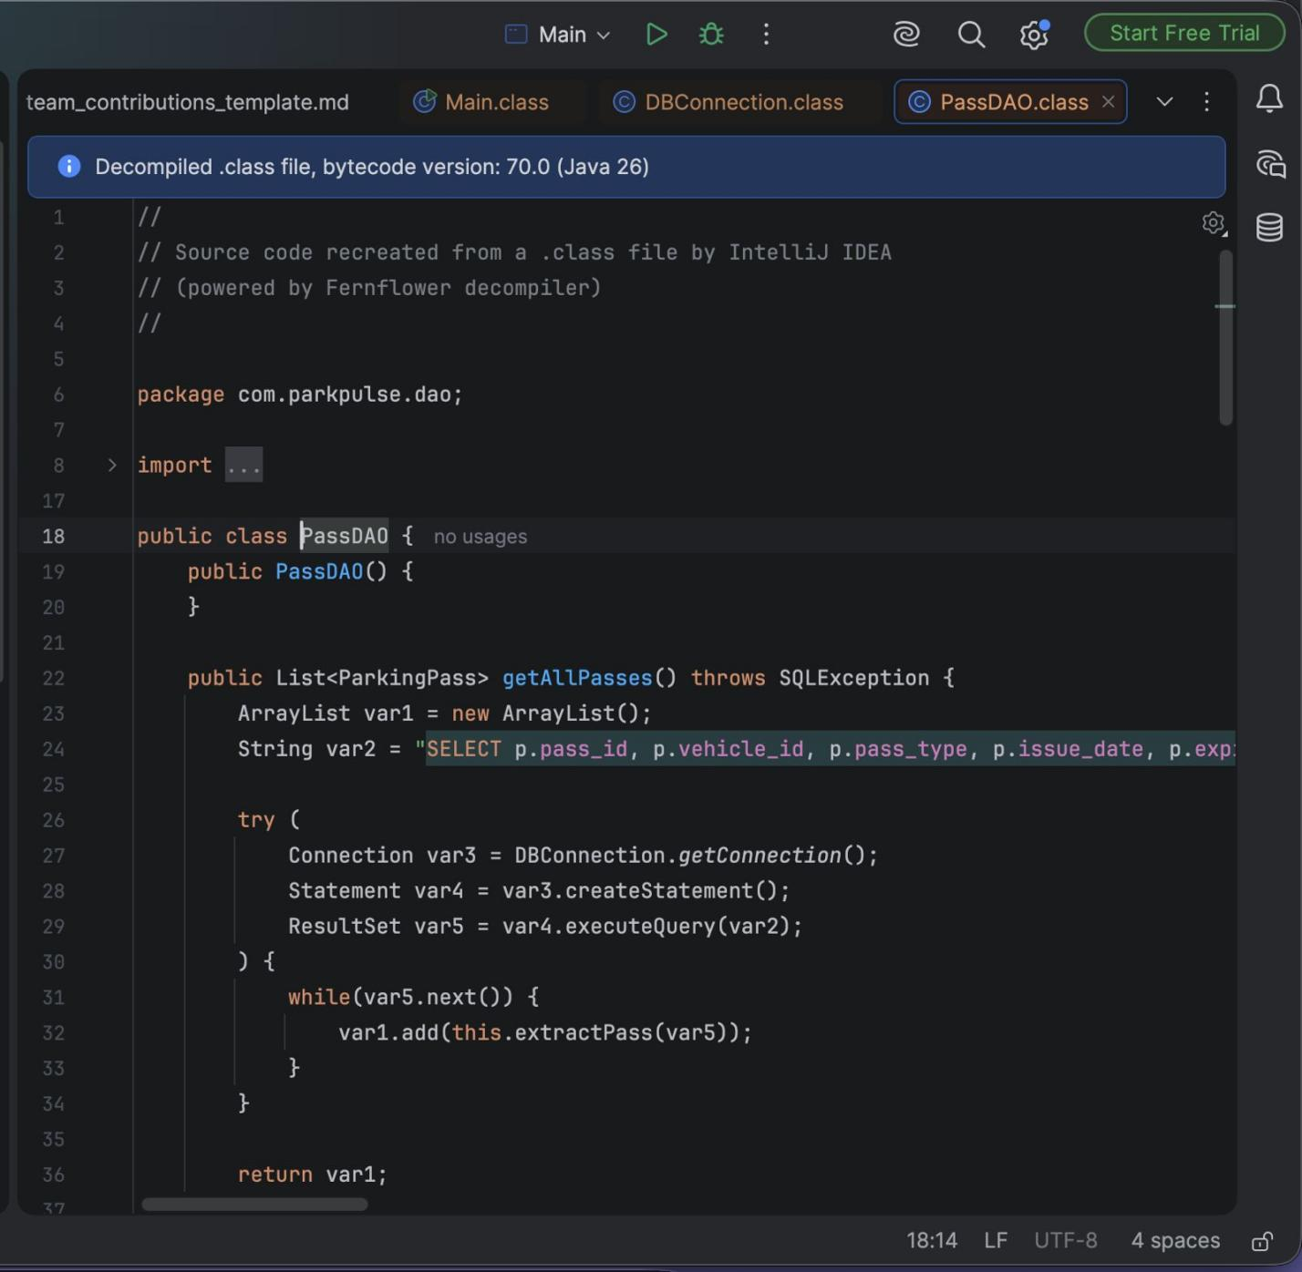

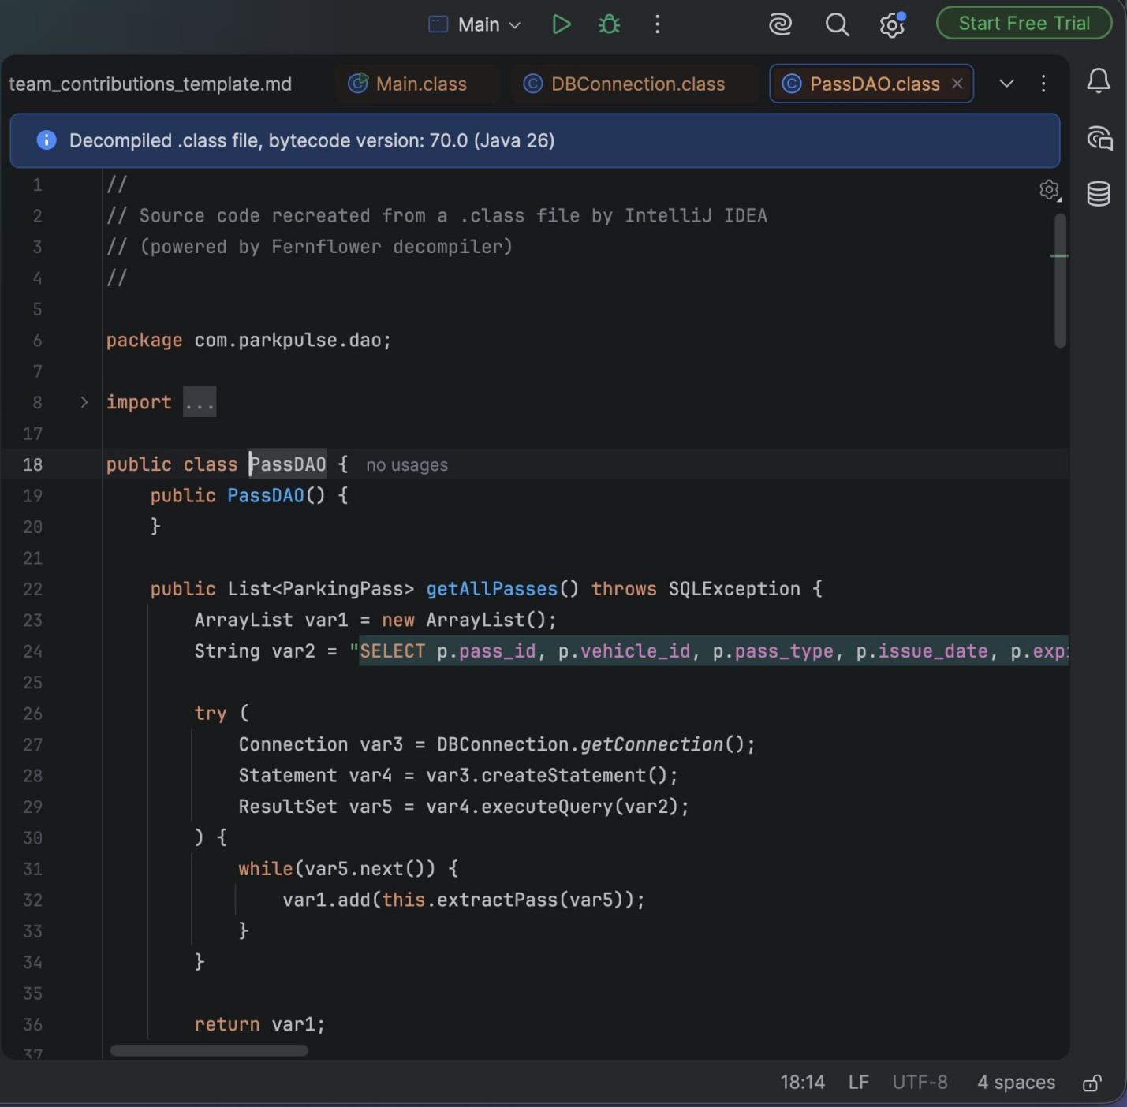

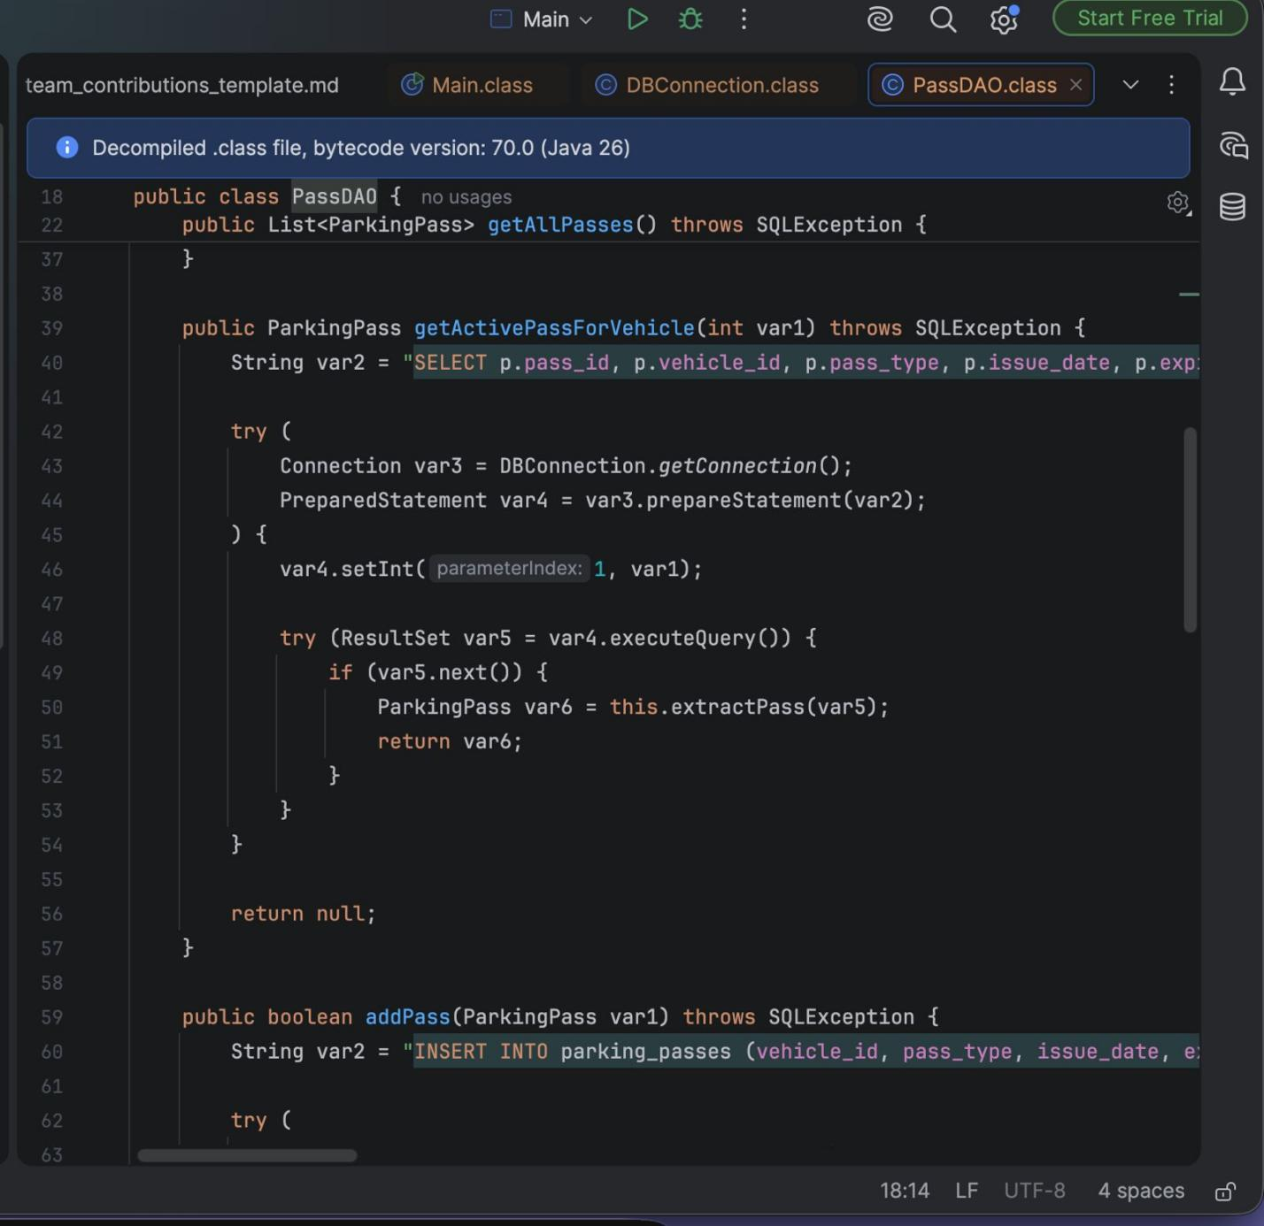

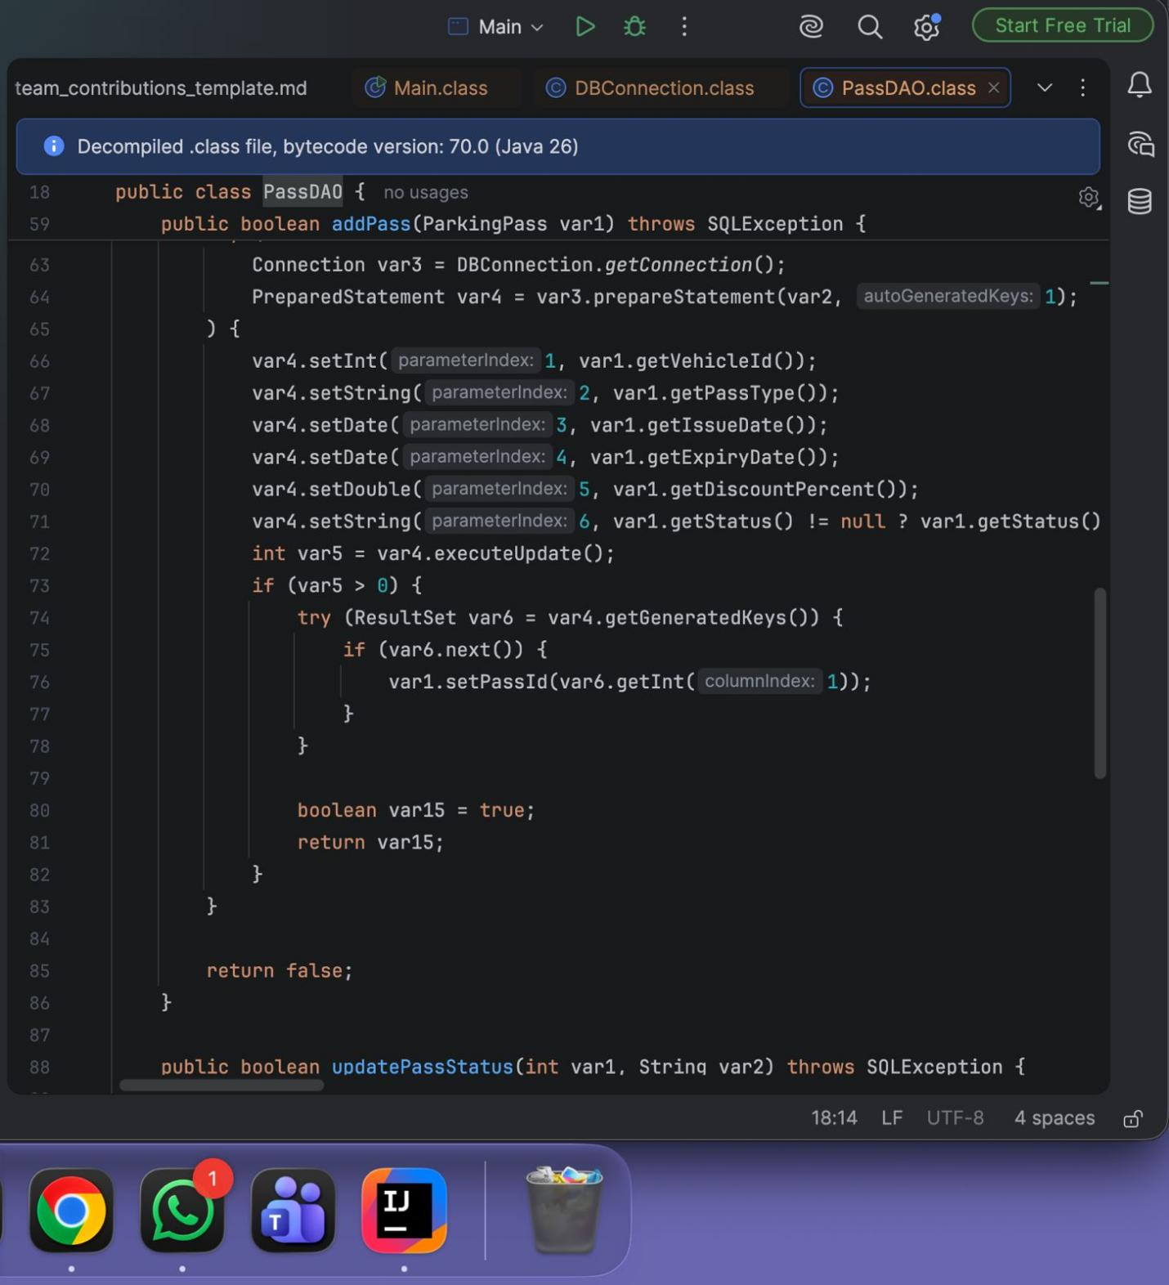

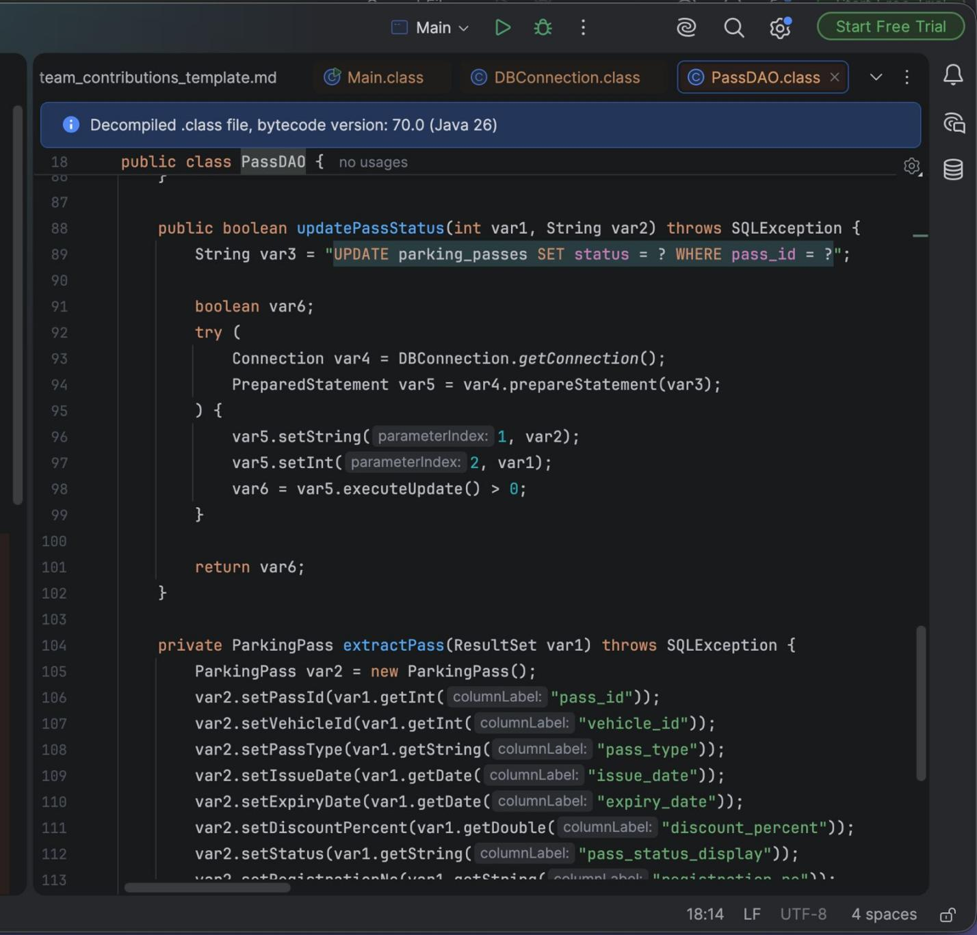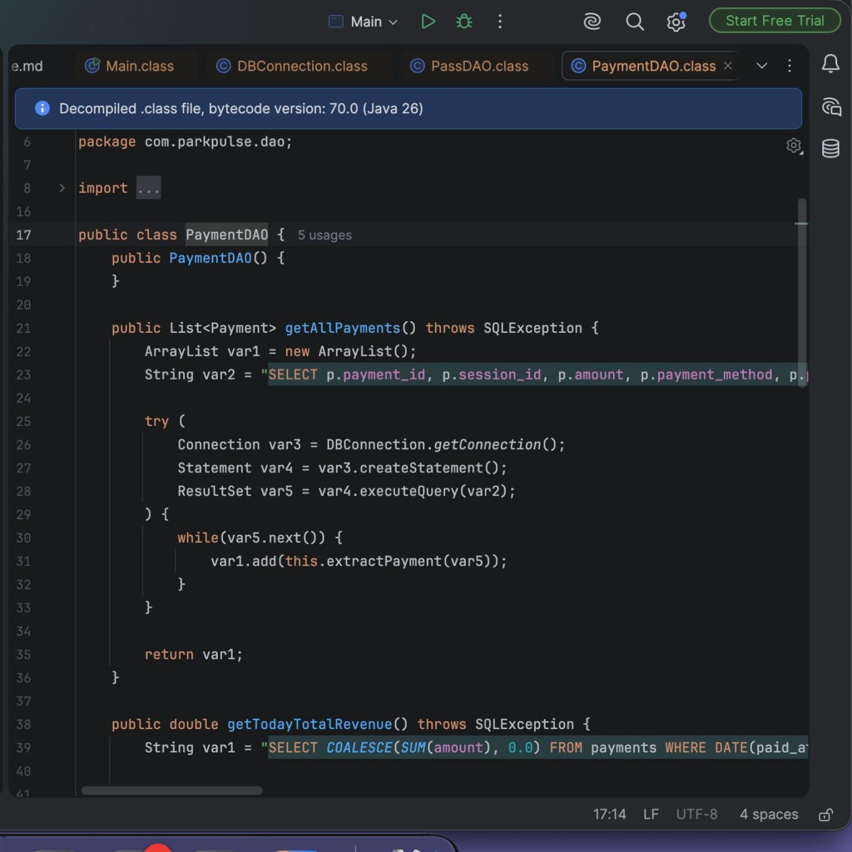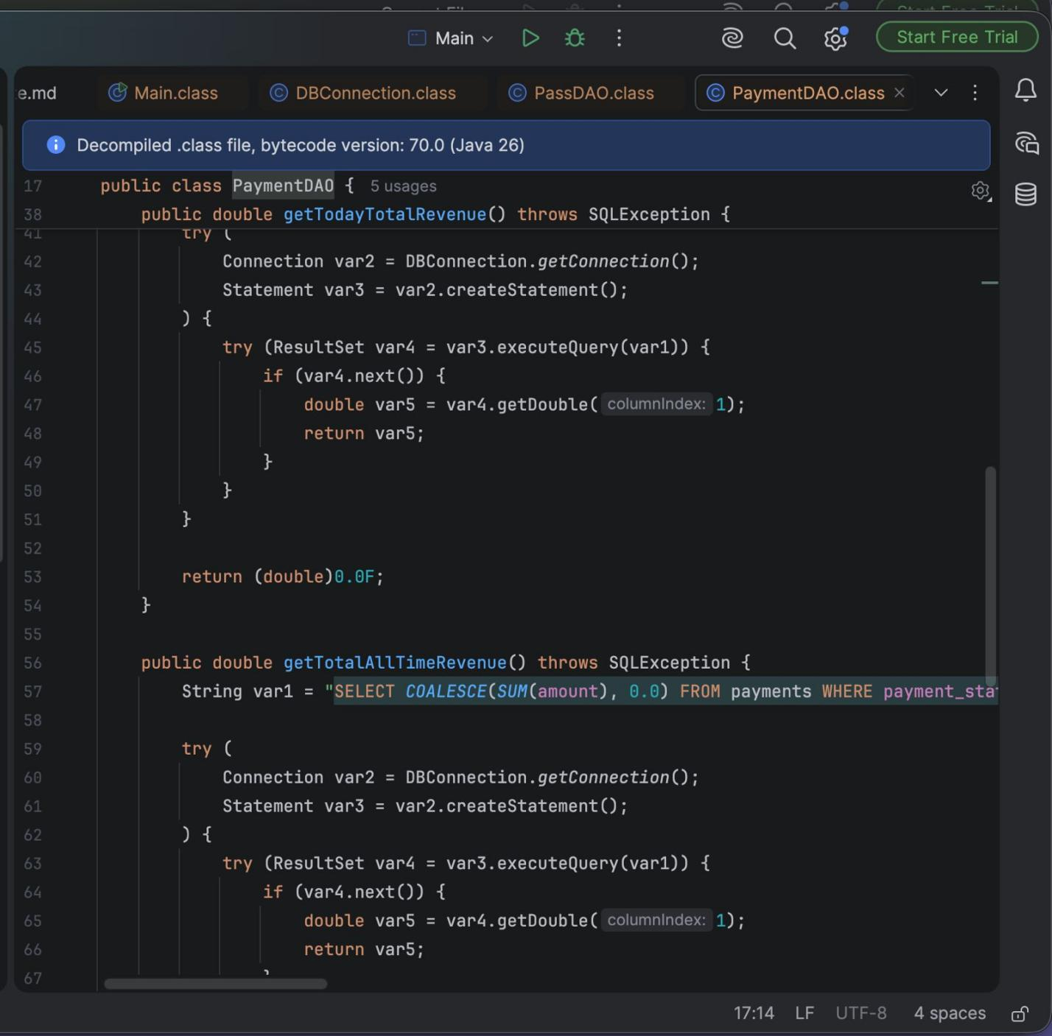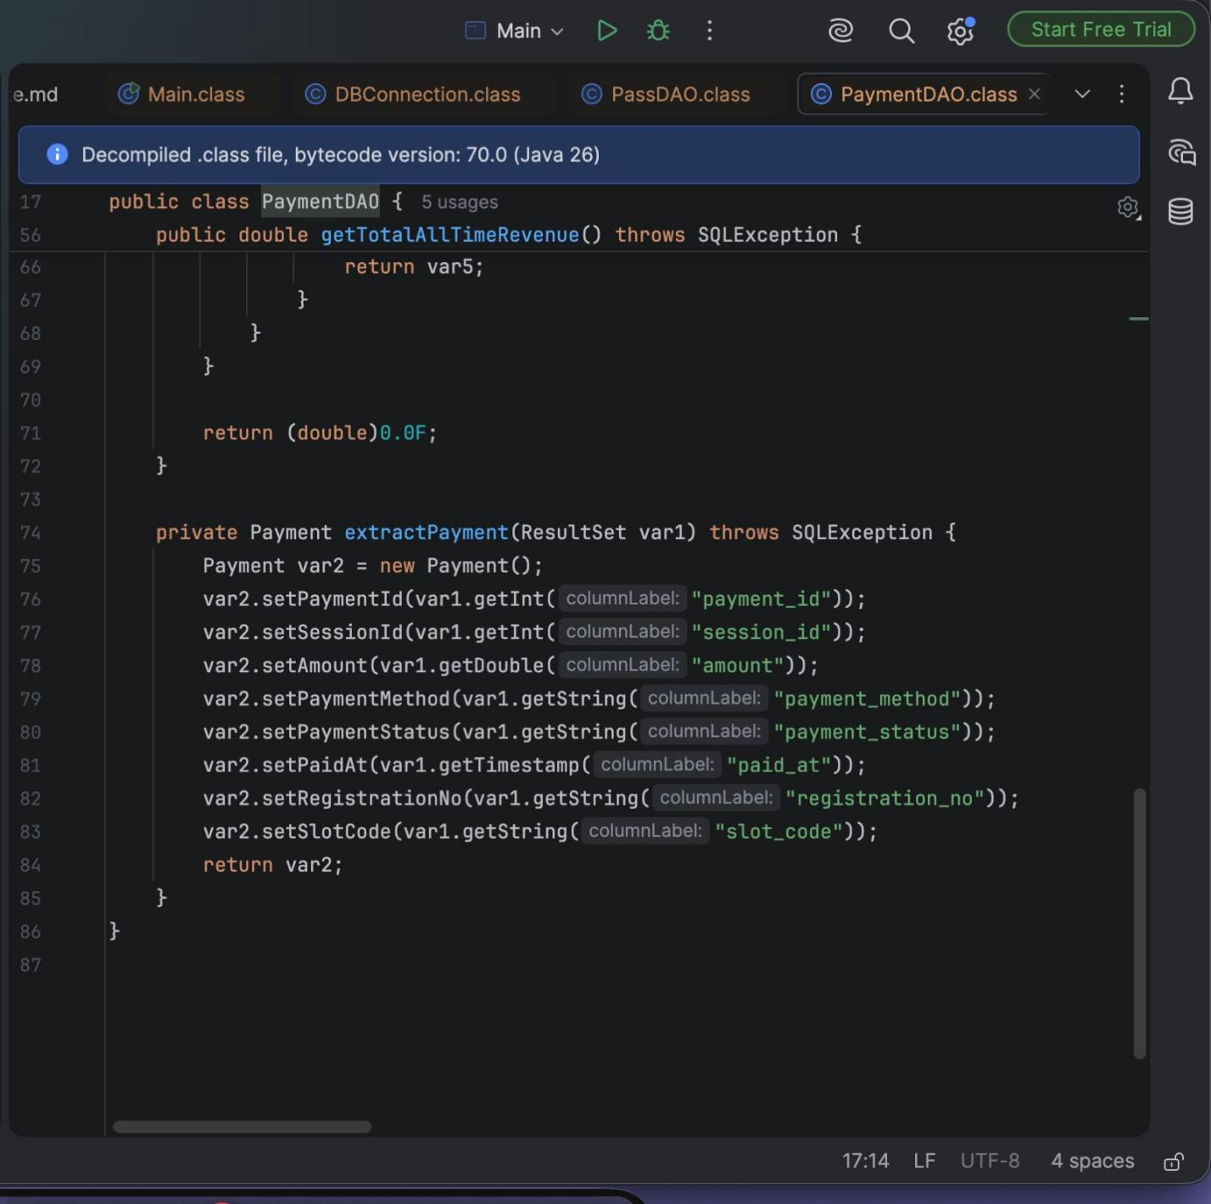

Workflow:
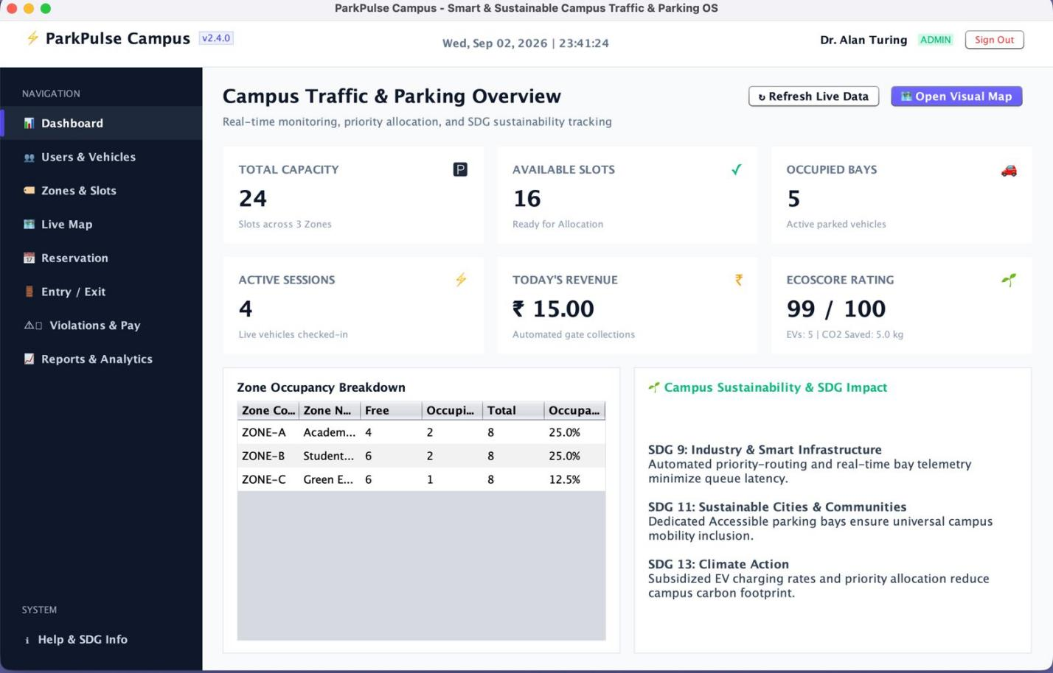

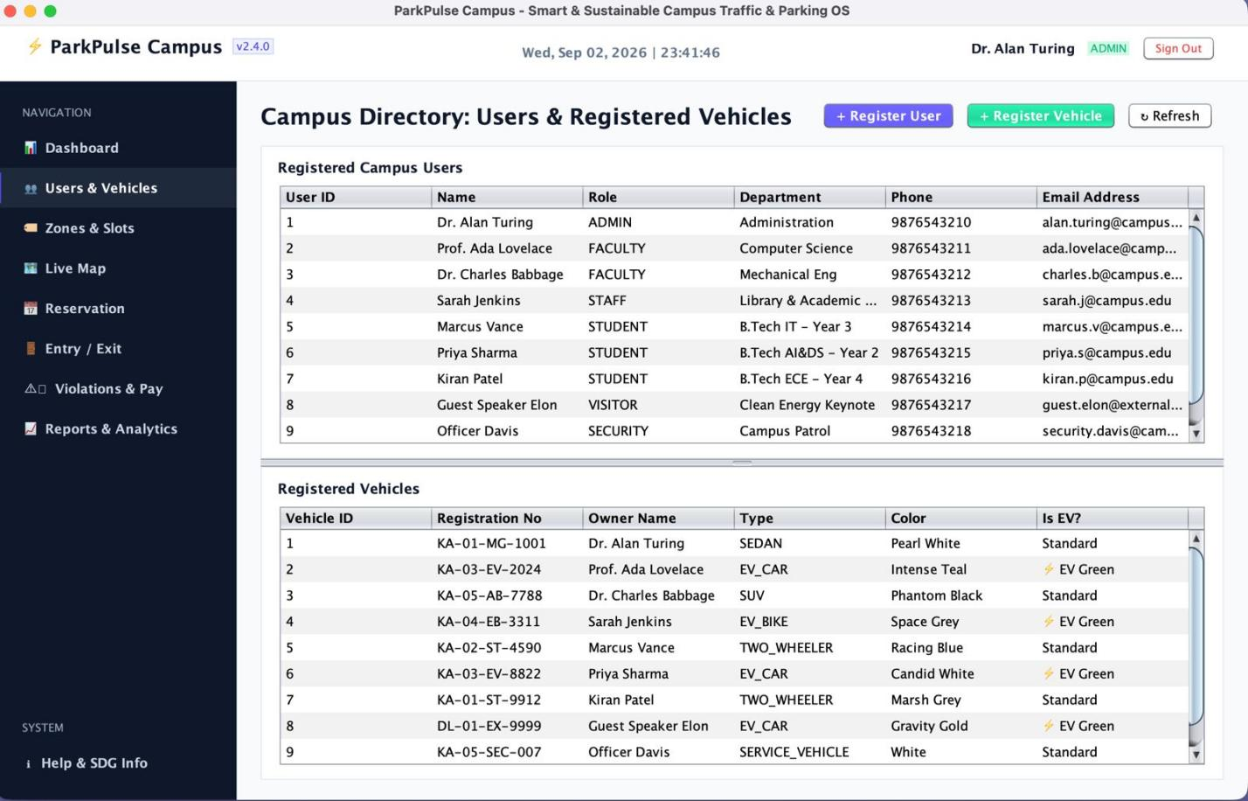

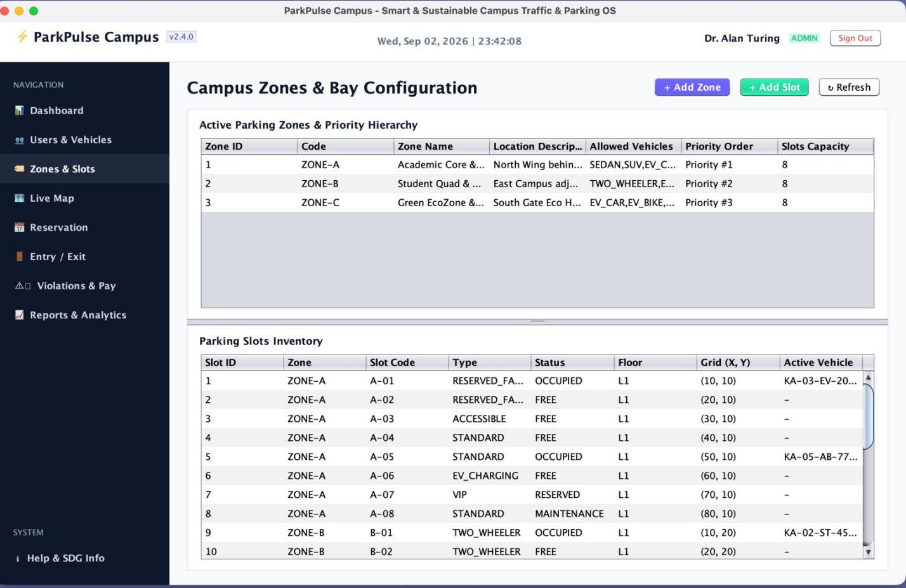

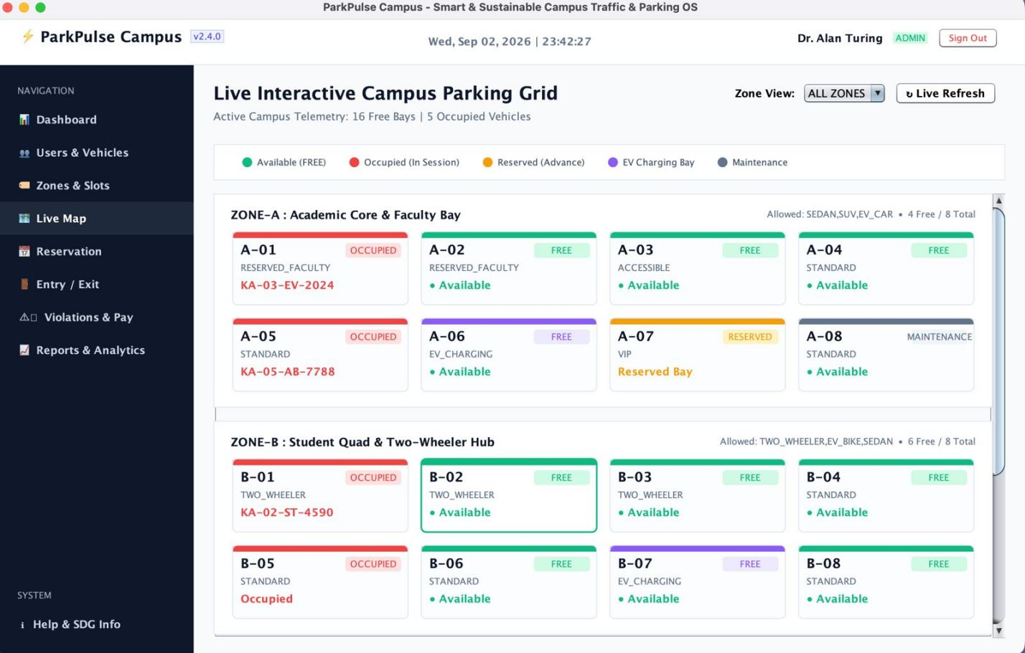

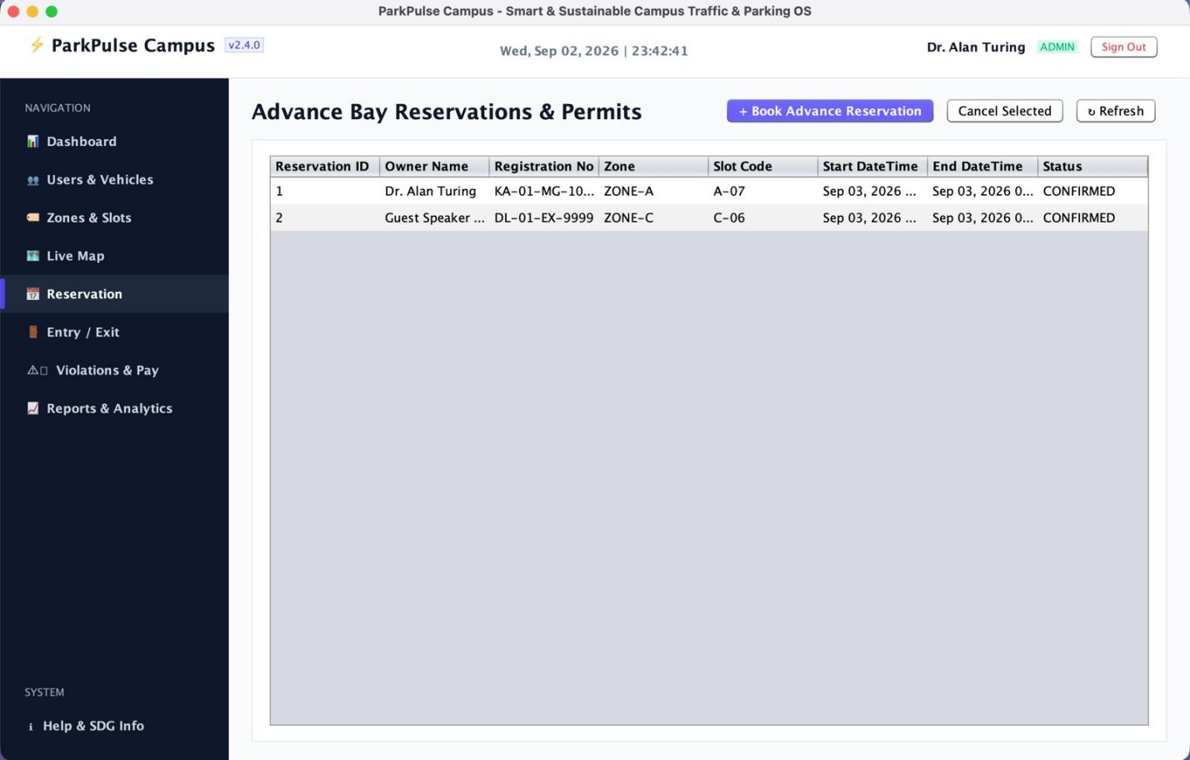

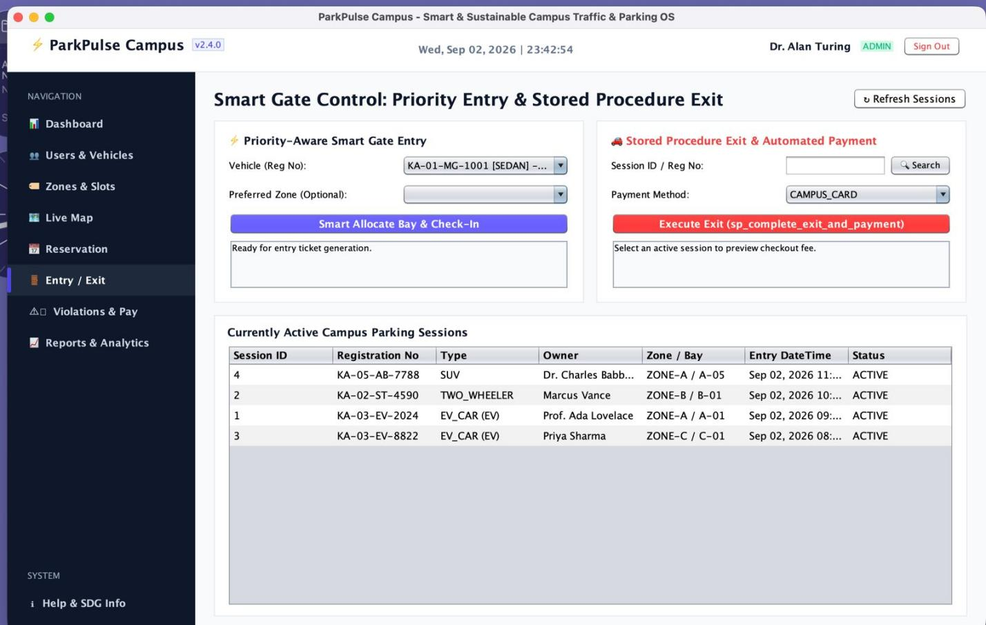

Student 1
Student Name: Nithish Raaju V
Register Number: 192411016
Project Title: ParkPulse Campus – Smart Campus Parking Management System

Individual Role/Contribution
I worked on the project as a Java developer and system integration developer. I was responsible for designing the overall application structure, implementing core modules, and integrating all components into the final ParkPulse Campus system.

Modules/Tasks Completed

Developed the core Java Swing application using IntelliJ IDEA.

Designed the overall system structure and module integration.

Implemented user and vehicle management functionalities.

Worked on parking zone and parking slot management modules.

Implemented parking reservation and parking session operations.

Developed database connectivity using JDBC and MySQL.

Implemented DAO classes for all major entities (User, Vehicle, Zone, Slot, Session, Reservation, Payment, Violation, Pass).

Implemented CRUD operations and basic input validation across modules.

Tested the complete application, identified errors, and corrected implementation issues.

Integrated all individual modules into a single working system.

Brief Description of Work
I contributed to the development of the main application and integration of the ParkPulse Campus system. I worked with Java classes responsible for users, vehicles, parking zones, parking slots, reservations, and parking sessions. I also implemented DAO-based database operations and ensured consistent communication between the UI and the database.
I tested the application functionality, identified errors, corrected implementation issues, and integrated the different modules so that they worked together as one complete system.

Outcome/Learning
Through this project, I gained practical experience in Java, OOP, JDBC, MySQL, DAO architecture, CRUD operations, debugging, testing, and system integration. I also improved my problem-solving and software development skills.

Student 2
Student Name: Pavithran M
Register Number: 192411014
Project Title: ParkPulse Campus – Smart Campus Parking Management System

Individual Role/Contribution
I worked as an Application Module and Testing Developer on the project. I focused on implementing key parking-related features, validating inputs, testing different scenarios, and helping integrate all modules into the final application.

Modules/Tasks Completed

Worked on parking slot and parking zone functionalities.

Contributed to reservation management (create, view, cancel).

Implemented parking session functionality (entry/exit flow).

Implemented parking violation management module.

Worked on vehicle-related operations (add, edit, delete, list).

Assisted with user management functionality.

Implemented validation for application inputs across forms.

Tested different system operations and scenarios (normal, boundary, and error cases).

Identified and reported errors during development and assisted in fixing them.

Assisted in integrating all modules into the final ParkPulse Campus application.

Brief Description of Work
I contributed to the development and testing of the parking management features of the ParkPulse Campus system. I worked with modules related to parking zones, parking slots, reservations, parking sessions, vehicles, and parking violations.
I also participated in testing the system using different scenarios, checking whether parking operations were working correctly, and identifying errors. I assisted in integrating the different modules with the main application and database.

Outcome/Learning
Through this project, I gained practical experience in Java programming, application development, parking management logic, database operations, input validation, testing, debugging, and system integration. I also improved my teamwork, communication, and problem-solving skills.

Student 3
Student Name: Papineni Sisindri
Register Number: 192324122
Project Title: ParkPulse Campus – Smart Campus Parking Management System

Individual Role/Contribution
I worked as a Database and Backend Developer on the project. I focused on the MySQL database design, backend components, and ensuring reliable data management for all parking-related operations.

Modules/Tasks Completed

Designed and worked on the MySQL database structure and schema.

Implemented database connectivity using JDBC.

Developed and maintained DAO classes for database operations.

Implemented parking pass management functionality.

Worked on parking session database operations (create, list, complete exit).

Implemented payment management and payment-related database operations.

Worked on reservation data management (create, update status, cancel).

Implemented CRUD operations for all required entities.

Tested database operations with different inputs and scenarios.

Identified and corrected database-related errors and assisted in backend integration.

Brief Description of Work
I contributed mainly to the backend and database-related functionality of the ParkPulse Campus system. I worked with the DAO classes responsible for communicating with the database and handling operations such as inserting, retrieving, updating, and deleting records.
I contributed to modules related to parking passes, parking sessions, reservations, and payments. I also tested database operations and helped identify and resolve errors during development. The backend components were integrated with the other modules to form the complete application.

Outcome/Learning
Through this project, I gained practical experience in Java backend development, MySQL, JDBC, DAO architecture, database operations, CRUD functionality, testing, debugging, and module integration. I also developed a better understanding of how application logic communicates with a relational database.

